Teacher Professional Development: One Big Idea and Five Core Strategies
- By Kathy Dyer
- December 17, 2012
Many of the formative assessment strategies and techniques that we’ve blogged about are what teachers can use to elicit evidence of student learning – the first step in understanding how they need to make changes in how they teach students. These formative assessment strategies are all born out of one big idea and five key strategies that not only make up our Keeping Learning on Track™ (KLT) embedded teacher professional development, but are the foundation for Black and Wiliams’ research in Inside the Black Box.
The one big idea is fundamental to improving student learning. That is, students and teachers continuously using evidence of learning to adapt what happens in the classroom. If educators can truly understand whether all students comprehend learning targets, they can effect positive change. The five key strategies that support this one big idea ultimately lead to the formative assessment strategies and techniques:
1. Clarifying, sharing, and understanding learning targets and success criteria. The students need to know what they are being taught, and what the measurements for success are, so setting expectations is crucial.
2. Engineering effective classroom discussions, questions, and learning tasks that elicit evidence of learning. This is certainly core to formative assessment techniques that ultimately get introduced into the classroom, but also a key part of the teacher professional development that KLT structures.
3. Providing feedback that moves learners forward. More than a grade, the feedback needs to be instructive and come not only from teachers but fellow students.
4. Activating students as the owners of their own learning. The students need to become involved in their own education and having them assess their own work can play a role in this. One of our previous blogs highlighted the research behind this thinking.
5. Activating students as instructional resources for one another. Collaboration among students is just as important as collaboration among teachers in improving student learning.
Breaking down teacher professional development into one big idea and five core strategies makes success achievable and realistic. By focusing one or two strategies at a time, and seeing what works in their classroom, teachers can share success collaboratively and improve student learning.
http://www.nwea.org/blog/2012/teacher-professional-development-one-big-idea-and-five-core-strategies/

Dylan Wiliam: Unpacking Formative Assessment
- By Kathy Dyer
- January 7, 2013
At Fusion 2012 back in June, Dylan Wiliam spoke about the general confusion that hangs over the definition of formative assessment. In fact, we even wrote a blog entitled What is Formative Assessment? to address this confusion and define what we think it means. Here’s our definition:
A planned practice to elicit evidence of learning minute to minute, day by day in the classroom; along with non-summative assessments that occur while content is still being taught. Both of these can inform teachers of what students know or do not know, help students understand what it is they are ready to learn next, so teachers can adjust their instruction accordingly for each of their students.
In his keynote at the event, Dylan touched on “unpacking” formative assessment. You can watch that excerpt below, but the visual here also unpacks it nicely, with the three tracks of where the learner is going, where the learner is, and how to get there, supported by the five strategies of formative assessment that we’ve also blogged about recently.

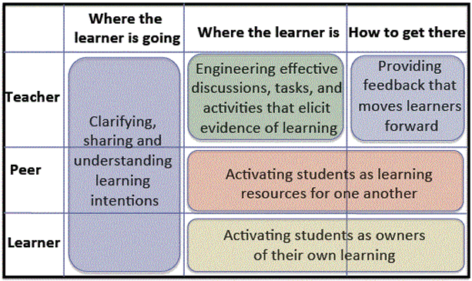

Dylan’s thoughts and the above illustration are really what make up our Keeping Learning on Track teacher professional development program. If you haven’t as yet checked it out and are looking for a teacher PD program for your school or district it might be worth a peek. We’d love your thoughts as well, so drop a comment below.
http://www.nwea.org/blog/2013/dylan-wiliam-unpacking-formative-assessment/

