Social Studies Standards
for the
Next Generation

Draft July 2014
Kentucky Core Academic Standards

Social Studies Standards for the Next Generation
Introduction
As young learners of the 21st century engage in the integrated study of the social sciences, it is critical that they are equipped with the dexterity of mind to question, evaluate and communicate what is necessary to become active, productive and engaged citizens in a culturally diverse, democratic society. Kentucky’s Social Studies Standards for the Next Generation will enable educators to design curriculum that enhances the students’ content knowledge while building critical thinking skills. These standards will empower 21st century learners to move beyond the acquisition of isolated facts while equipping them with the dispositions necessary to become stewards of democracy as citizens in an interdependent world.
Disciplinary Core Concepts
Kentucky’s Social Studies Standards for the Next Generation answers the demand of educators to reimagine what students learn and how they learn. These standards have identified Disciplinary Core Concepts (DCCs), derived from the C3 Framework, Global Competence Matrix, and the Partnership for 21st Century Skills, as the methods in which social scientist engage in disciplinary thinking. Kentucky’s Social Studies Standards for the Next Generation use the DCCs to define the content of the social studies discipline as the development of: Civic Mindedness (CM), Economic Decision Making (EDM), Geographic Reasoning (GR) and Historical Thinking (HT).
Inquiry Cycle
Kentucky’s Social Studies Standards for the Next Generation builds a paradigm of teaching and learning that asks learners to be meaningfully engaged in the practices in the Inquiry Cycle: Questioning, Evaluating and Communicating while accessing and developing Disciplinary Core Concepts. The components of the Inquiry Practices frame the Disciplinary Core Concepts to construct opportunities to critically think about and collaborate on fundamental aspects of what it means to be college, career and civic ready. The outcomes from such rich and meaningful learning experiences will better prepare future citizens to communicate and creatively resolve the problems of our world, while also accessing the DCCs of the social sciences.
Crosscutting Threads
It is the responsibility of social studies educators to support the development of active citizens who participate productively in the world around them. It is essential that all Kentucky students are globally-prepared and ready to support communities and companies with citizens and workers who understand how to cooperate and compete in an increasingly global economy. Kentucky’s Social Studies Standards for the Next Generation attempts to meet these needs by infusing the following crosscutting threads into both the Inquiry Practices and the Disciplinary Core Concepts: Global Competency, 21st Century Skills, and Local to Global Scale Connections.

College, Career and Civic Ready Anchor Standards
1 | Civic and Political Institutions  Determine the importance of the institutions of society and the principles that these institutions are intended to reflect, which requires the demonstration of in-depth understanding of law, politics, and government.
2 | Participation and Deliberation: Applying Civic Virtues and Democratic Principles  Analyze foundational documents and determine key understandings in order to evaluate how citizens should interact with each other in formal institutions and informal interactions.
3 | Processes, Rules and Laws  Evaluate and critique how decisions, procedures, and policies are used to address problems and/or needs in a variety of settings.
4 | Economic Decision Making  Analyze and explain how resource availability, opportunity cost, and incentives are an essential part of economic decision making.
5 | Exchange and Markets  Analyze how the interactions of buyers and sellers in a variety of economic markets impact goods, services, labor, created and foreign exchange in the markets; evaluate and critique the effectiveness of government policies on market outcomes.
6 | National Economy  Analyze and explain how the amounts and qualities of capital (human and physical) and natural resources influence current and future economic conditions as well as standards of living by evaluating and critiquing the intended and unintended consequences of policies on: fluctuations, growth, supply, spending, inflation, employment and growth.
7 | Global Economy  Analyze and explain the benefits and costs of globalization among individuals and businesses (considering specialization and trade) and how this leads to increased economic interdependence (cross-border movement of goods, services, technology, information and human, physical and financial capital).
8 | Spatial Views of the World  Create and utilize maps and other geographical representations to seek and communicate new knowledge that is personally and socially useful.
9 | Human-Environment Interaction  Determine how society is impacted at local-to-global scales through the interactions of human and physical systems.
10 | Human Populations: Spatial Patterns and Movements  Analyze the movements and spatial patterns of human populations (size, composition, distribution) to determine the relationships between these spatial patterns and physical, political, economic and technological phenomenon.
11 | Global Interconnections: Changing Spatial Patterns  Evaluate the dynamic interactions among the world’s people, nations and economic organizations and how they impact global scale issues.
12 | Chronological Reasoning: Causation and Continuity  Analyze similarities and differences between historical periods and between the past and present, to determine processes of change and continuity over time by evaluating the causation of political, social, economic, cultural and intellectual factors.
13 | Historical Understanding: Contextualization and Perspectives  Evaluate historical developments by analyzing a multiplicity of points of view to gain a broader historical perspective of regional, national and global processes.
14 | Historical Arguments  Utilize evidence to craft claims that demonstrate an analysis and evaluation of sources, taking into consideration change over time, perspectives of those involved and relevance of sources.
15 | Interpretation and Synthesis  Evaluate the multiplicity of historical points of view, context and circumstances through the use of a wide range of sources in order to create a synthesis of the past, while applying insights from the present.

“Why?”

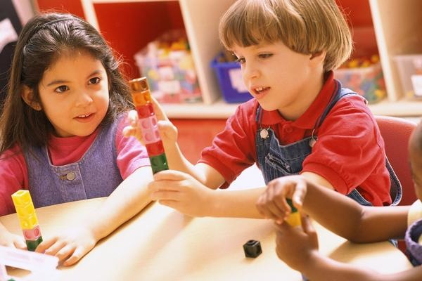
The goal for 21st century learners in Kindergarten is to wonder and reason, which are the initial building blocks of a rich foundation of inquiry. By embracing the theme of “Why” throughout the school year, these students will question, evaluate and take action on a wide range of experiences. The expectation for our students is to see the world connected through the Disciplinary Core Concepts and to begin a path towards college, career, and civic readiness. Through intentional Inquiry Cycle experiences, students are encouraged to question and evaluate the decisions made by them and those around them. Throughout the Inquiry Cycle, students will come to the understanding of civic-mindedness through questioning rules and evaluating roles. Students will use their personal experiences to generate possible reasons for events, leading to the idea that historical events are driven by cause and effect. By connecting everyday classroom experiences to economic decision-making, young learners will be able to question and evaluate the motivations behind these decisions. Also, students will investigate relationships between the environment and their community. Over the course of a series of experiences, students will begin to develop the essential practices of determining compelling questions and evaluating information to plan and implement appropriate actions to address authentic problems.

Kindergarten: Why?
Practices in the Inquiry Cycle
Questioning  Students will independently and collaboratively:  1. Develop compelling questions that promote inquiry around key disciplinary concepts and embedded enduring issues.  2. Develop supporting questions that identify facts, concepts and research interpretations associated with a key disciplinary concept.  3. Determine the types of sources that will assist in answering compelling and supporting questions. | Evaluating Sources  Students will independently and collaboratively:  4. Gather relevant information from multiple sources from a wide range of perspectives and evaluate for credibility.  5. Identify and utilize evidence to seek solutions to questions.  6. Develop and create claims and counterclaims using appropriate evidence to construct strengths and weaknesses |  | Communicating  Students will independently and collaboratively:  7. Construct viable arguments, relevant explanations and/or public demonstrations that convey ideas and perspectives to a wide array of appropriate audiences.  8. Critique the arguments and explanations of others paying particular attention to credibility and relevance of information.  9. Address options of individuals and groups to identify and apply a range of strategies and complex reasoning to take public action or propose a solution.
10. Engage in disciplinary thinking used by social scientists (historians, economists, political scientists and geographers) independently and proficiently resulting in civic readiness.
Civic Mindedness |  | Geographic Reasoning
K.CM.1 Civic and Political Institutions Identify the roles and responsibilities of community members.  K.CM.2 Participation and Deliberation: Applying Civic Virtues and Democratic Principles Describe how people treat each other, then practice respect for authority and peers.  K.CM.3 Processes, Rules and Laws Describe rules in various settings. |  | K.GR.8 Spatial Views of the World Create maps, graphs and other models of familiar places.  K.GR.9 Human-Environment Interaction Identify environmental characteristics including weather and climate and explain how they affect peoples’ lives in a place or region.  K. GR. 10 Human Populations Spatial Patterns and Movements Explain why and how people, goods and ideas move from place to place.  K. GR. 11 Global Interconnections Identify ways that a catastrophic disaster may affect people living in a place.
Economic Decision Making |  | Historical Thinking
K.EDM.4 Economic Decision Making Explain how scarcity affects resources to lead individuals to make choices.  K.EDM.5 Exchange and Markets Explain how people use income to purchase goods and services.  K.EDM.6 National Economy Explain why people save and spend money.  K.EDM.7 Global Economy Describe goods and services. |  | K. HT.12 Chronological Reasoning: Causation and Continuity Create a chronological sequence and generate a possible cause for the event.  K.HT.13 Historical Understanding: Contextualization and Perspectives Compare different perspectives of people.  K.HT.14 Historical Arguments Identify a possible reason for historical events and developments.  K.HT.15 Interpretation and Synthesis Identify different kinds of historical sources.

“How?”

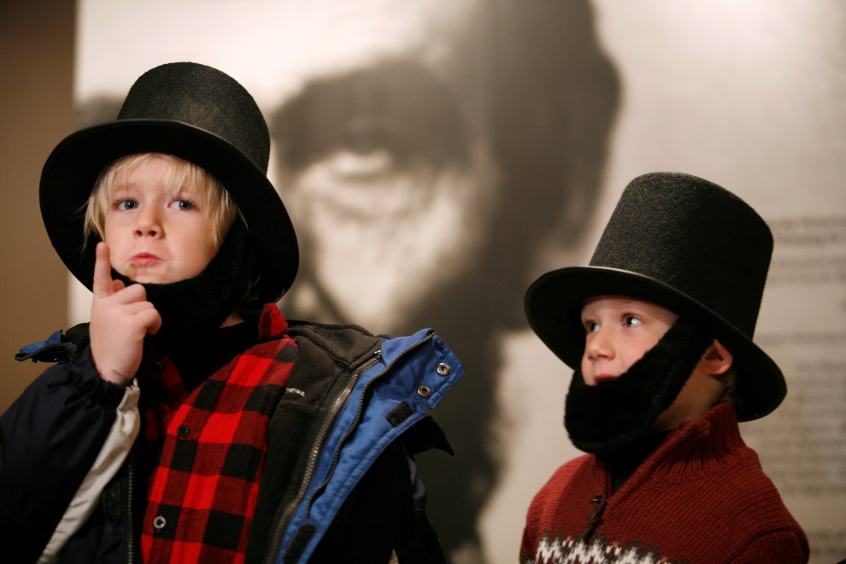
Building on their experiences of Wonder and Reason from Kindergarten, 1st graders will engage in 21st Century Learning, deepening their learning in all elements of the Inquiry Cycle. Experiences throughout the school year will create opportunities for students to question how roles and responsibilities in their community relate to rules and decision-making, develop historical-thinking skills by questioning and evaluating sources, foster economic decision-making by asking questions and evaluating their role as a consumer, and develop geographic-reasoning skills that will challenge students to see relationships between cultures and the environment This year of wonder and investigation will lead to the development of an understanding of HOW these concepts affect their world and empower students to see themselves as contributors to the solutions.

Grade 1: How?
Practices in the Inquiry Cycle
Questioning  Students will independently and collaboratively:  1. Develop compelling questions that promote inquiry around key disciplinary concepts and embedded enduring issues.  2. Develop supporting questions that identify facts, concepts and research interpretations associated with a key disciplinary concept.  3. Determine the types of sources that will assist in answering compelling and supporting questions. | Evaluating Sources  Students will independently and collaboratively:  4. Gather relevant information from multiple sources from a wide range of perspectives and evaluate for credibility.  5. Identify and utilize evidence to seek solutions to questions.  6. Develop and create claims and counterclaims using appropriate evidence to construct strengths and weaknesses |  | Communicating  Students will independently and collaboratively:  7. Construct viable arguments, relevant explanations and/or public demonstrations that convey ideas and perspectives to a wide array of appropriate audiences.  8. Critique the arguments and explanations of others paying particular attention to credibility and relevance of information.  9. Address options of individuals and groups to identify and apply a range of strategies and complex reasoning to take public action or propose a solution.
10. Engage in disciplinary thinking used by social scientists (historians, economists, political scientists and geographers) independently and proficiently resulting in civic readiness.
Civic Mindedness |  | Geographic Reasoning
1.CM.1 Civic and Political Institutions Explain the need for and purposes of rules in a community.  1.CM.2 Participation and Deliberation: Applying Civic Virtues and Democratic Principles Describe and demonstrate equality, fairness, and freedom when making decisions.  1.CM.3 Processes, Rules and Laws Explain the purpose of rules in various settings. |  | 1.GR.8 Spatial Views of the World Identify cultural and environmental characteristics of places using maps, graphs, photographs and other models.  1.GR.9 Human-Environment Interaction Identify some cultural and environmental characteristics of specific places.  1.GR.10 Human Populations Spatial Patterns and Movements Compare the economic activities of various communities and their impact on daily needs.  1.GR.11 Global Interconnections Explain how the consumption of products connects people to distant places through trade.
Economic Decision Making |  | Historical Thinking
1.EDM.4 Economic Decision Making Explain and generate examples of how scarcity affects economic decisions.  1.EDM.5 Exchange and Markets Describe the connection between the costs of production and the price of goods and services.  1.EDM.6 National Economy Describe examples of goods and services.  1.EDM.7 Global Economy Describe why people trade for goods and services. |  | 1. HT.12 Chronological Reasoning: Causation and Continuity Utilizing a chronological sequence, compare life today to the past and identify significant individuals and groups.  1.HT.13 Historical Understanding: Contextualization and Perspectives Compare perspectives of people in the past to those of people in the present.  1.HT.14 Historical Arguments Summarize possible reasons for historical events and developments to happen by viewing a *historical source.  1.HT.15 Interpretation and Synthesis Identify the maker, date and place of origin for a historical source from information in the source while explaining how the source can be used to study the past.

“Explore and Discover My Role”

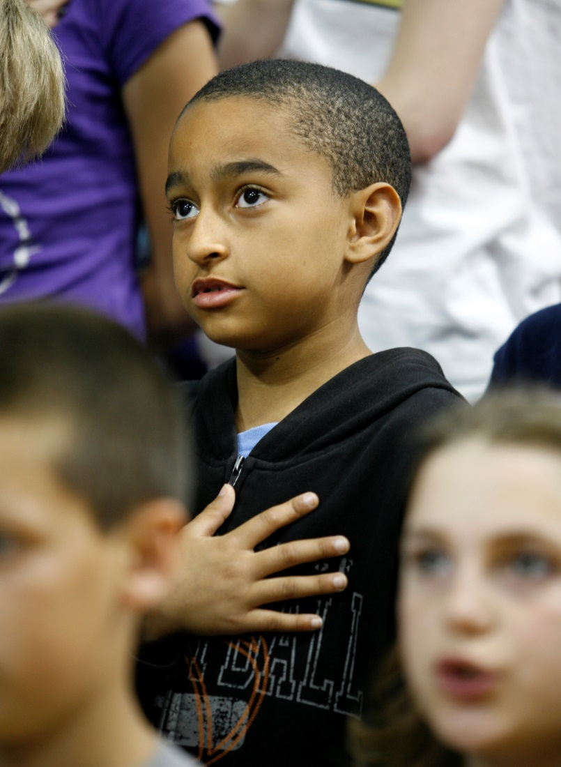
With students developing a keen sense of “Why” and “How”, 21st century learners in 2nd grade will continue to foster their understanding of their role in the world. By creating experiences and opportunities for students to practice the Inquiry Cycle across the four Disciplinary Core Concepts, the essential skills for college, career, and civic readiness will be established. Students will explore and question why and how people and governments make decisions that benefit their communities; analyze the process of production, distribution, and consumption; determine how goods and services may be taken for granted; discover how human-environmental interactions affect their understanding of the world; how the world changes as a result of physical characteristics and human activities; begin to interrogate historical sources and to develop understandings of the cause and effect relationships that affect their lives.
The instructional experiences these students encounter in 2nd grade throw open the windows of discovery to propel students toward understanding the variety of ways we interact with the world around us.

Grade 2: Explore and Discover My Role
Practices in the Inquiry Cycle
Questioning  Students will independently and collaboratively:  1. Develop compelling questions that promote inquiry around key disciplinary concepts and embedded enduring issues.  2. Develop supporting questions that identify facts, concepts and research interpretations associated with a key disciplinary concept.  3. Determine the types of sources that will assist in answering compelling and supporting questions. | Evaluating Sources  Students will independently and collaboratively:  4. Gather relevant information from multiple sources from a wide range of perspectives and evaluate for credibility.  5. Identify and utilize evidence to seek solutions to questions.  6. Develop and create claims and counterclaims using appropriate evidence to construct strengths and weaknesses |  | Communicating  Students will independently and collaboratively:  7. Construct viable arguments, relevant explanations and/or public demonstrations that convey ideas and perspectives to a wide array of appropriate audiences.  8. Critique the arguments and explanations of others paying particular attention to credibility and relevance of information.  9. Address options of individuals and groups to identify and apply a range of strategies and complex reasoning to take public action or propose a solution.
10. Engage in disciplinary thinking used by social scientists (historians, economists, political scientists and geographers) independently and proficiently resulting in civic readiness.
Civic Mindedness |  | Geographic Reasoning
2.CM.1 Civic and Political Institutions Explain what governments are and how communities work to accomplish tasks and establish responsibilities.  2.CM.2 Participation and Deliberation: Applying Civic Virtues and Democratic Principles Compare individual and group perspective and how they affect decisions.  2.CM.3 Processes, Rules and Laws Describe how people have tried to improve their communities through rules or laws. |  | 2.GR.8 Spatial Views of the World Describe places and the relationships and interactions that shape them using maps, graphs, photographs and other models.  2.GR.9 Human-Environment Interaction Explain how human activities in local-to-global communities affect cultural and environmental characteristics.  2.GR.10 Human Populations Spatial Patterns and Movements Describe connections between the physical environment and the economic activities of a location.  2.GR.11 Global Interconnections Describe how changes in physical and cultural characteristics of world regions affect people.
Economic Decision Making |  | Historical Thinking
2.EDM.4 Economic Decision Making Describe opportunity costs of economic decisions.  2.EDM.5 Exchange and Markets Identify examples of human, capital and natural resources to explain why individuals and businesses specialize and trade.  2.EDM.6 National Economy Describe how examples of capital, human and natural resources are related to goods and services.  2.EDM.7 Global Economy Describe products imported and exported. |  | 2.HT.12 Chronological Reasoning: Causation and Continuity Create and utilize a chronological sequence to generate possible causes for events and developments and how these were shaped by individuals and groups of the past.  2.HT.13 Historical Understanding: Contextualization and Perspectives Compare different accounts of the same historical event.  2.HT.14 Historical Arguments Determine which reasons cause historical events and developments to happen using a secondary source.  2.HT.15 Interpretation and Synthesis Generate questions about a historical source and explain how the source is related to a historical development or event.

“Working Together"

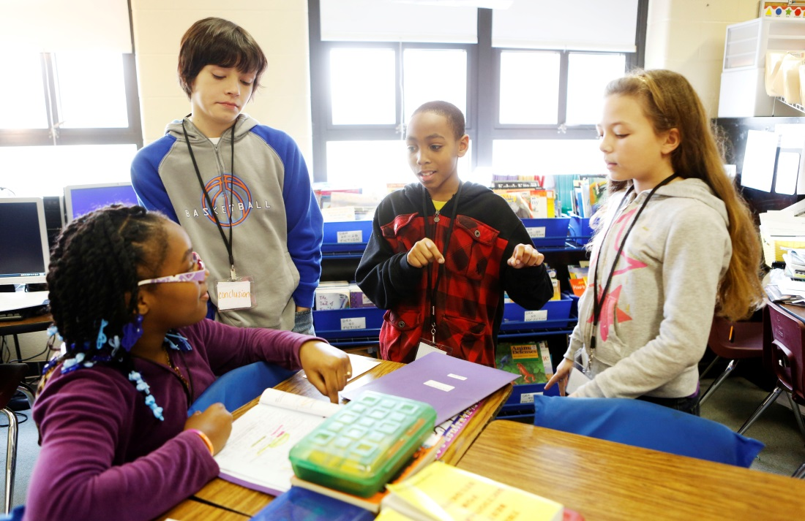
To continue the foundation for college, career, and civic readiness, the goal for 21st Century Learners in 3rd grade is to continue to refine questioning and evaluating skills, while building a broader understanding of the world around them. Through the concept of rules and authority, students are now ready to investigate how collaboration in a community and the establishment of various responsibilities are necessary to build and achieve a functioning society. Using their understanding of rules and authority, students will build a schema for democracy by continuing to ask the all-important ‘why’ questions, but they are also exploring how ideas, events, and people are connected; how they all "work together". As students examine how events from the past shape the future, they will also evaluate how their own understandings are shaped by the past. These engaged learners will use their understandings of the world to contextualize historical sources and establish connections. They will analyze and evaluate how trade influences decision-making and why people exchange goods and services. In addition, these 21st century learners will come to an understanding that the physical environment plays a pivotal role in determining how society has developed over time. Most significantly, through the Inquiry Cycle, students will take informed action on issues that arise from the home, school, and/or community and work collaboratively to address them.

Grade 3: Working Together
Practices in the Inquiry Cycle
Questioning  Students will independently and collaboratively:  1. Develop compelling questions that promote inquiry around key disciplinary concepts and embedded enduring issues.  2. Develop supporting questions that identify facts, concepts and research interpretations associated with a key disciplinary concept.  3. Determine the types of sources that will assist in answering compelling and supporting questions. | Evaluating Sources  Students will independently and collaboratively:  4. Gather relevant information from multiple sources from a wide range of perspectives and evaluate for credibility.  5. Identify and utilize evidence to seek solutions to questions.  6. Develop and create claims and counterclaims using appropriate evidence to construct strengths and weaknesses |  | Communicating  Students will independently and collaboratively:  7. Construct viable arguments, relevant explanations and/or public demonstrations that convey ideas and perspectives to a wide array of appropriate audiences.  8. Critique the arguments and explanations of others paying particular attention to credibility and relevance of information.  9. Address options of individuals and groups to identify and apply a range of strategies and complex reasoning to take public action or propose a solution.
10. Engage in disciplinary thinking used by social scientists (historians, economists, political scientists and geographers) independently and proficiently resulting in civic readiness.
Civic Mindedness |  | Geographic Reasoning
3.CM.1 Civic and Political Institutions  Explain how citizens responsibly participate in democratic processes and practice civic responsibility.  3.CM.2 Participation and Deliberation: Applying Civic Virtues and Democratic Principles  Practice civic virtues, democratic principles, and respect for various perspectives.  3.CM.3 Processes, Rules and Laws  Compare decision-making procedures in a variety of settings. |  | 3.GR.8 Spatial Views of the World Construct various geographical representations of both familiar and unfamiliar places.  3.GR.9 Human-Environment Interaction Explain how the culture of a place or region influences how people modify and adapt to their environment.  3.GR.10 Human Populations Spatial Patterns and Movements Explain how human settlements and movements relate to the availability of natural resources.  3.GR.11 Global Interconnections Explain why environmental characteristics vary among different world regions.
Economic Decision Making |  | Historical Thinking
3.EDM.4 Economic Decision Making Explain how economic decisions are affected by opportunity costs.  3.EDM.5 Exchange and Markets Explain the role of money and financial institutions in economic markets.  3.EDM.6 National Economy Describe ways people can increase productivity by using improved capital goods and human capital.  3.EDM.7 Global Economy Describe and give examples of economic interdependence. |  | 3.HT.12 Chronological Reasoning: Causation and Continuity Create and use chronological sequence of events to explain probable cause and effects of those events or developments.  3.HT.13 Historical Understanding: Contextualization and Perspectives Compare and explain why individuals and groups during the same historical period differed in their perspectives.  3.HT.14 Historical Arguments Investigate and explain the concept of a claim about the past by examining a secondary source.  3.HT.15 Interpretation and Synthesis Compare information provided by different historical sources about the past.

“Relationships”

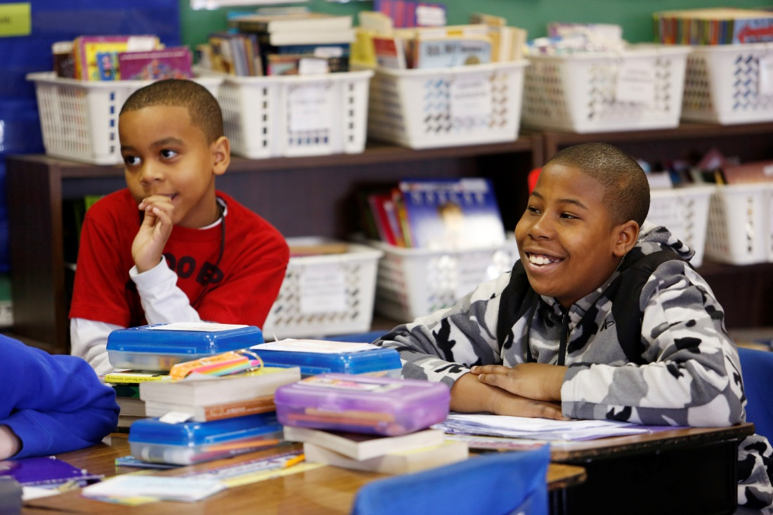
After developing independent thinking skills and collaboration skills, the goal for 21st Century Learners in 4th grade is to continue to foster curiosity and engagement by creating experiences to interact with and evaluate the relationships between perspective, change and interdependence and how these ideas impact an individual and a society.
Students will continue to focus on questioning as they consider perspectives and how these impact the reasons for “why” people create and make changes to rules and laws to meet the needs of society. They will question and evaluate perspective and context as they continue to examine historical sources to sharpen historical-thinking skills. By building on the understandings of scarcity, opportunity costs and human capital, 21st century learners will develop questions to investigate how the relationships between buyers and sellers, trade and specialization, and changes to human capital impact economic decision-making. Using geographic tools, students will examine how the cultural, environmental and man-made characteristics impact humanity’s interaction with its surroundings. As students continue to refine their ability to question, evaluate and communicate, they will utilize school and community relationships to identify and address issues that affect students' lives. Students will understand that the purpose of civic-readiness is the process of learning how to engage with and meet the needs of the community.

Grade 4: Relationships
Practices in the Inquiry Cycle
Questioning  Students will independently and collaboratively:  1. Develop compelling questions that promote inquiry around key disciplinary concepts and embedded enduring issues.  2. Develop supporting questions that identify facts, concepts and research interpretations associated with a key disciplinary concept.  3. Determine the types of sources that will assist in answering compelling and supporting questions. | Evaluating Sources  Students will independently and collaboratively:  4. Gather relevant information from multiple sources from a wide range of perspectives and evaluate for credibility.  5. Identify and utilize evidence to seek solutions to questions.  6. Develop and create claims and counterclaims using appropriate evidence to construct strengths and weaknesses |  | Communicating  Students will independently and collaboratively:  7. Construct viable arguments, relevant explanations and/or public demonstrations that convey ideas and perspectives to a wide array of appropriate audiences.  8. Critique the arguments and explanations of others paying particular attention to credibility and relevance of information.  9. Address options of individuals and groups to identify and apply a range of strategies and complex reasoning to take public action or propose a solution.
10. Engage in disciplinary thinking used by social scientists (historians, economists, political scientists and geographers) independently and proficiently resulting in civic readiness.
Civic Mindedness |  | Geographic Reasoning
4.CM.1 Civic and Political Institutions Describe the origins, functions, and structure of state government to determine how it supports freedom within a democracy.  4.CM.2 Participation and Deliberation: Applying Civic Virtues and Democratic Principles Compare the beliefs, experiences and values that affect individual and group perspectives.  4.CM.3 Processes, Rules and Laws Explain how communities are improved by developing policies to meet the needs of society. |  | 4.GR.8 Spatial Views of the World Describe the locations of cultural and environmental characteristics using maps of different scales.  4.GR.9 Human-Environment Interaction Explain how cultural and environmental characteristics of places change over time.  4.GR.10 Human Populations Spatial Patterns and Movements Explain how cultural and environmental characteristics affect the distribution and movement of people, goods and ideas.  4.GR.11 Global Interconnections Explain how natural and human-made catastrophic events in one place affect people living in other places.
Economic Decision Making |  | Historical Thinking
4.EDM.4 Economic Decision Making Describe the relationship between resource availability, incentives and opportunity costs.  4.EDM.5 Exchange and Markets Explain the roles of buyers and sellers in product, labor and financial markets.  4.EDM.6 National Economy Explain ways in which government pays for the goods and services it provides and analyze the impact of these goods and services on standards of living.  4.EDM.7 Global Economy Explain how trade leads to increasing economic interdependence among nations. |  | 4.HT.12 Chronological Reasoning: Causation and Continuity Explain probable causes and effects of events or developments, creating and using a chronological sequence of events and compare life from specific historical periods to life today.  4.HT.13 Historical Understanding: Contextualization and Perspectives Explain connections among historical contexts and people’s perspectives at the time.  4.HT.14 Historical Arguments Identify evidence from a secondary source to summarize a claim about the past.  4.HT.15 Interpretation and Synthesis Analyze the information gathered from historical sources (maker, date, place of origin, audience and purpose), to judge the extent to which the sources are useful for studying a particular topic.

“Change and Impact”

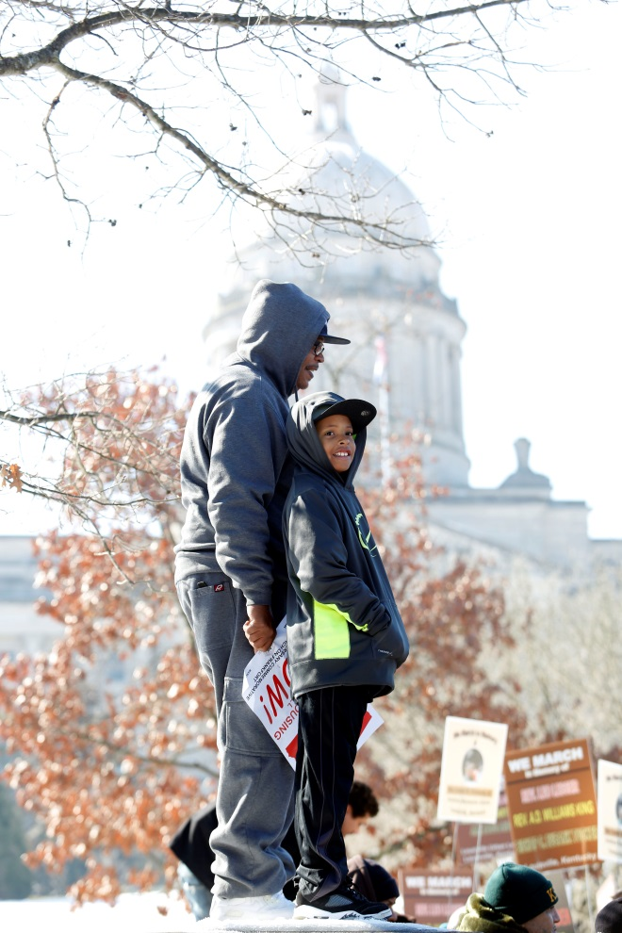
Once a sense of self and the importance of relationships are established for civic-readiness, the goal for 21st Century Learners in 5th grade is to use the Inquiry Cycle to examine the idea of change.
This close examination will not only focus on who, why and how of events but ultimately the outcomes of these events: the impacts of change. While investigating the power of change, students will develop a sense of civic-mindedness by examining how and why groups and individuals work to establish better forms of government; refine historical-thinking skills by interpreting historical sources to generate insights on why change occurs; search to explain how the influence of groups and individuals factor into economic decision-making; and apply geographic-reasoning by conducting inquiries into how cultural and environmental outcomes change over time and are impacted by natural and man-made events.
Most importantly students will utilize the Practices within the Inquiry Cycle to create meaningful opportunities to take informed-action. These practices allow students to impact an outcome; to make change.

Grade 5: Change and Impact
Practices in the Inquiry Cycle
Questioning  Students will independently and collaboratively:  1. Develop compelling questions that promote inquiry around key disciplinary concepts and embedded enduring issues.  2. Develop supporting questions that identify facts, concepts and research interpretations associated with a key disciplinary concept.  3. Determine the types of sources that will assist in answering compelling and supporting questions. | Evaluating Sources  Students will independently and collaboratively:  4. Gather relevant information from multiple sources from a wide range of perspectives and evaluate for credibility.  5. Identify and utilize evidence to seek solutions to questions.  6. Develop and create claims and counterclaims using appropriate evidence to construct strengths and weaknesses |  | Communicating  Students will independently and collaboratively:  7. Construct viable arguments, relevant explanations and/or public demonstrations that convey ideas and perspectives to a wide array of appropriate audiences.  8. Critique the arguments and explanations of others paying particular attention to credibility and relevance of information.  9. Address options of individuals and groups to identify and apply a range of strategies and complex reasoning to take public action or propose a solution.
10. Engage in disciplinary thinking used by social scientists (historians, economists, political scientists and geographers) independently and proficiently resulting in civic readiness.
Civic Mindedness |  | Geographic Reasoning
5.CM.1 Civic and Political Institutions Explain how government effects how citizens, political and economic groups function within society.  5.CM.2 Participation and Deliberation: Applying Civic Virtues and Democratic Principles Use intentional procedures when making decisions and reaching judgments as an individual and as a group.  5.CM.3 Processes, Rules and Laws Using historical and contemporary examples, explain how rules and law promote the common good. |  | 5.GR.8 Spatial Views of the World Explain relationships between the locations of places and regions and their environmental characteristics using maps, satellite images and other models.  5.GR.9 Human-Environment Interaction Describe how changing environmental and cultural characteristics of places and regions influence how people modify and adapt to their environments and impact population distribution.  5.GR.10 Human Populations Spatial Patterns and Movements Analyze the effects of devastating environmental and technological events on human settlement and movement.  5.GR.11 Global Interconnections Describe how the spatial patterns of economic activities in a place change over time because of interactions with nearby and distant places.
Economic Decision Making |  | Historical Thinking
5.EDM.4 Economic Decision Making Evaluate economic decisions using cost-benefit analysis.  5.EDM.5 Exchange and Markets Describe the role of competition in the determination of prices/wages and explain how profits influence sellers in a market.  5.EDM.6 National Economy Describe the functions of the monetary system in personal, local and national economies.  5.EDM.7 Global Economy Analyze the effects of increasing economic interdependence on different groups within participating nations. |  | 5.HT.12 Chronological Reasoning: Causation and Continuity Analyze and explain probable causes of individuals and groups’ impacts on significant historical developments or events.  5.HT.13 Historical Understanding: Contextualization and Perspectives Explain how connections among historical contexts and people’s perspectives influenced the development of historical sources during the same historical time period.  5.HT.14 Historical Arguments Develop historical claims utilizing evidence from*historical sources.  5.HT.15 Interpretation and Synthesis Infer the intended audience and purpose of a historical source by sourcing the document in order to generate questions about how it relates to particular events and developments.

"Making Meaning"

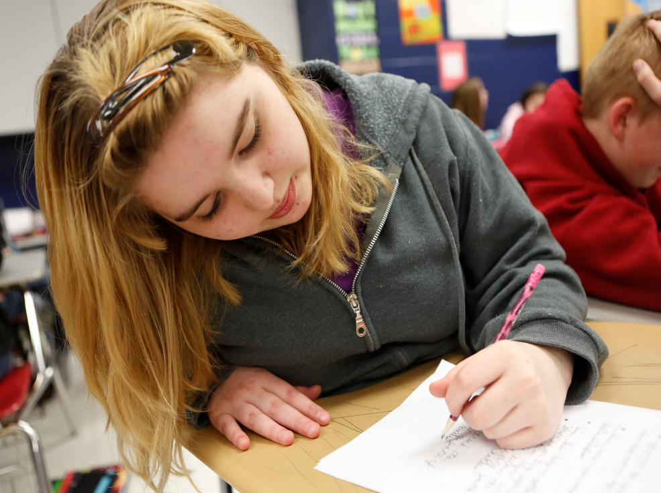
As students continue to thrive in environments that encourage them to wonder and reason, the goal for 21st Century Learners in 6th grade is to search for ways to understand why change occurs and to question and evaluate in order to make meaning of this change. Students will seek to understand how the government functions to serve the best interest of the common good and continue to engage in disciplinary thinking by investigating how humans interact with their environments throughout various regions of the world and analyzing their findings to determine impacts. They will engage in experiences that allow them to develop an understanding of how economic decisions affect the well being of individuals and society as a whole. Drawing on both, Inquiry Practices and their ability to engage in historical thinking, students will seek to generate their own questions and launch investigations that will allow them to uncover their own explanations of why change occurs.
Students will need to routinely use Inquiry Cycle Practices in order to develop these essential understandings but also plan, implement, and reflect on informed-action. Together, the power of Disciplinary Core Concepts and the Inquiry Cycle Practices will empower students to not only understand true citizenship, but also but also to recognize that they themselves are citizens with the power and responsibility to impact their communities.

Grade 6: Making Meaning
Practices in the Inquiry Cycle
Questioning  Students will independently and collaboratively:  1. Develop compelling questions that promote inquiry around key disciplinary concepts and embedded enduring issues.  2. Develop supporting questions that identify facts, concepts and research interpretations associated with a key disciplinary concept.  3. Determine the types of sources that will assist in answering compelling and supporting questions. | Evaluating Sources  Students will independently and collaboratively:  4. Gather relevant information from multiple sources from a wide range of perspectives and evaluate for credibility.  5. Identify and utilize evidence to seek solutions to questions.  6. Develop and create claims and counterclaims using appropriate evidence to construct strengths and weaknesses |  | Communicating  Students will independently and collaboratively:  7. Construct viable arguments, relevant explanations and/or public demonstrations that convey ideas and perspectives to a wide array of appropriate audiences.  8. Critique the arguments and explanations of others paying particular attention to credibility and relevance of information.  9. Address options of individuals and groups to identify and apply a range of strategies and complex reasoning to take public action or propose a solution.
10. Engage in disciplinary thinking used by social scientists (historians, economists, political scientists and geographers) independently and proficiently resulting in civic readiness.
Civic Mindedness |  | Geographic Reasoning
6.CM.1 Civic and Political Institutions Examine the origins, functions and structure of the U.S. Constitution to determine how it supports freedoms within a society.  6.CM.2 Participation and Deliberation: Applying Civic Virtues and Democratic Principles Explain how personal interests, civic virtues, and democratic principles influence decisions.  6.CM.3 Processes, Rules and Laws Determine the procedures for making civic decisions based on the needs of society. |  | 6.GR.8 Spatial Views of the World Explain spatial patterns between places and regions as well as changes in their cultural and environmental characteristics using geographical representations.  6.GR.9 Human-Environment Interaction Explain how the physical and human characteristics of places and regions are connected to human identities and cultures.  6. GR. 10 Human Populations Spatial Patterns and Movements Explain how transportation and communication technology influence spatial connections among human settlement and affect the diffusion of ideas and cultural practices.  6. GR. 11 Global Interconnections Analyze the ways cultural and environmental characteristics vary among regions of the world.
Economic Decision Making |  | Historical Thinking
6.EDM.4 Economic Decision Making Explain how economic decisions affect the well-being of individuals and society.  6.EDM.5 Exchange and Markets Explain how changes in supply and demand cause fluctuation in prices, the production of goods and services, labor, credit and currencies.  6.EDM.6 National Economy Explain the influence of changes in interest rates on borrowing and investing.  6.EDM.7 Global Economy Explain barriers to trade and how those barriers influence trade among nations. |  | 6.HT.12 Chronological Reasoning: Causation and Continuity Analyze connections among historical events and developments in order to classify them as examples of change and continuity.  6.HT.13 Historical Understanding: Contextualization and Perspectives Analyze primary and secondary sources to explain how and why perspectives of people have changed over time.  6.HT.14 Historical Arguments Create an argument about the past that is supported by possible evidence generated from *historical sources.  6.HT.15 Interpretation and Synthesis Classify the kinds of historical sources used in a secondary interpretation and analyze them to identify further areas of inquiry and additional sources.

"Cause and Effect"
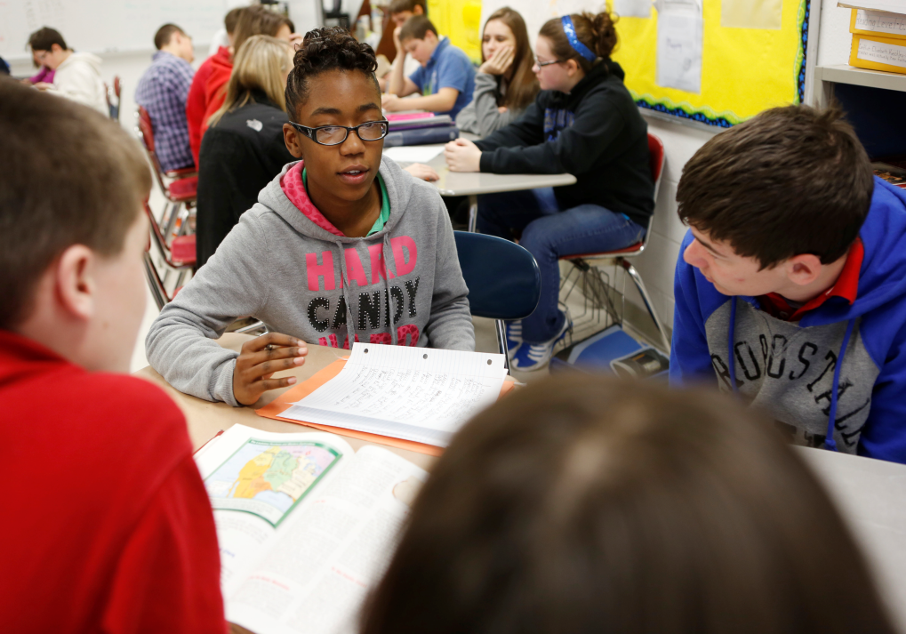
As students are empowered as leaders of their own educational experience, the goal for 21st Century Learners in 7th grade will be to consider deeply the cause of why things happen in addition to thoughtfully examining the effects of these decisions. Students in the seventh grade will look beyond their national borders to develop an understanding of society from a global perspective by creating inquiries and evaluating information to formulate new insights. 21st century learners will seek to deeply understand how economic decisions are reached through the critical analysis of market outcomes on a national and global scale. As students seek to support and develop their explanations with evidence, they turn toward an examination of critical historical events that may provide them with the insight necessary to develop and support a claim that showcases their ability to analyze and embrace the disciplinary thinking required of a social scientist.
Additionally, the seventh grade experience catapults students into the Inquiry Cycle by utilizing the Inquiry Practices and by planning, implementing, and reflecting upon informed-action. 21st Century Learners need opportunities and experiences that empower them to access and apply complex understandings in order to fully connect the power of causation.

Grade 7: Cause and Effect
Practices in the Inquiry Cycle
Questioning  Students will independently and collaboratively:  1. Develop compelling questions that promote inquiry around key disciplinary concepts and embedded enduring issues.  2. Develop supporting questions that identify facts, concepts and research interpretations associated with a key disciplinary concept.  3. Determine the types of sources that will assist in answering compelling and supporting questions. | Evaluating Sources  Students will independently and collaboratively:  4. Gather relevant information from multiple sources from a wide range of perspectives and evaluate for credibility.  5. Identify and utilize evidence to seek solutions to questions.  6. Develop and create claims and counterclaims using appropriate evidence to construct strengths and weaknesses |  | Communicating  Students will independently and collaboratively:  7. Construct viable arguments, relevant explanations and/or public demonstrations that convey ideas and perspectives to a wide array of appropriate audiences.  8. Critique the arguments and explanations of others paying particular attention to credibility and relevance of information.  9. Address options of individuals and groups to identify and apply a range of strategies and complex reasoning to take public action or propose a solution.
10. Engage in disciplinary thinking used by social scientists (historians, economists, political scientists and geographers) independently and proficiently resulting in civic readiness.
Civic Mindedness |  | Geographic Reasoning
7.CM.1 Civic and Political Institutions Explain how the U.S. Constitution structures the powers and limitations of government and defines powers and responsibilities of citizens.  7.CM.2 Participation and Deliberation: Applying Civic Virtues and Democratic Principles Compare deliberative processes when making decisions and reaching judgments as an individual and in groups for diverse situations.  7.CM.3 Processes, Rules and Laws Compare historical and contemporary methods of changing society to promote the common good. |  | 7.GR.8 Spatial Views of the World Construct geographical representations and analyze the spatial patterns regarding cultural and environmental characteristics.  7.GR.9 Human-Environment Interaction Explain how cultural patterns and economic decisions influence environments and daily lives of people in both nearby and distant places.  7. GR. 10 Human Populations Spatial Patterns and Movements Analyze how relationships between humans and environments extend or contract spatial patterns of settlement and movement.  7. GR. 11 Global Interconnections Explain how global changes in population distribution influence land use.
Economic Decision Making |  | Historical Thinking
7.EDM.4 Economic Decision Making Evaluate approaches to solve various economic problems and offer alternative solutions.  7.EDM.5 Exchange and Markets Describe how changes in supply and demand fuels innovation and entrepreneurship and explain how external benefits and costs influence market outcomes.  7.EDM.6 National Economy Explain the impact of interest rates on borrowing and investing, inflation, deflation and unemployment.  7.EDM.7 Global Economy Analyze the benefits and costs of trade policies and specialization to individuals, businesses, and society. |  | 7. HT.12 Chronological Reasoning: Causation and Continuity Analyze and explain why the causes and effects of historical events and developments are seen as significant by other individuals, groups and historical periods.  7.HT.13 Historical Understanding: Contextualization and Perspectives Analyze multiple factors that influenced the perspectives of people during different historical eras and explain how and why perspectives of people have changed over time.  7.HT.14 Historical Arguments Create an argument about the past that is supported by relevant evidence generated from *historical and multimedia sources.  7.HT.15 Interpretation and Synthesis Infer sourcing-information from other historical sources for a historical source where information is not easily identified.

"Participating In Change"

Young leaders who have been encouraged to wonder, question, analyze and communicate their understanding are now ready to embrace their role in creating and sustaining change that will have positive implications in their communities, nation and world. The goal for 21st Century Learners in 8th grade is that through the application of the Inquiry Cycle, students will demonstrate their development of Civic-Mindedness by clearly articulating the significance of civic participation and explaining how these processes are encouraged in order to address societal needs. Students will seek to expand their global perspective by analyzing how humans interact with their environment in ways that create long-term, human induced change. They will also begin to explore their role in this change as they seek to develop an understanding of the role that economic issues play on their nation and their world. These critical thinkers will uncover and effectively utilize data that support their analysis and lead to the development of informed opinions that will determine how they choose to participate in change that will have an impact on their society. These 21st century learners will embrace change and take necessary steps to move this change into action.

Grade 8: Participating in Change
Practices in the Inquiry Cycle
Questioning  Students will independently and collaboratively:  1. Develop compelling questions that promote inquiry around key disciplinary concepts and embedded enduring issues.  2. Develop supporting questions that identify facts, concepts and research interpretations associated with a key disciplinary concept.  3. Determine the types of sources that will assist in answering compelling and supporting questions. | Evaluating Sources  Students will independently and collaboratively:  4. Gather relevant information from multiple sources from a wide range of perspectives and evaluate for credibility.  5. Identify and utilize evidence to seek solutions to questions.  6. Develop and create claims and counterclaims using appropriate evidence to construct strengths and weaknesses |  | Communicating  Students will independently and collaboratively:  7. Construct viable arguments, relevant explanations and/or public demonstrations that convey ideas and perspectives to a wide array of appropriate audiences.  8. Critique the arguments and explanations of others paying particular attention to credibility and relevance of information.  9. Address options of individuals and groups to identify and apply a range of strategies and complex reasoning to take public action or propose a solution.
10. Engage in disciplinary thinking used by social scientists (historians, economists, political scientists and geographers) independently and proficiently resulting in civic readiness.
Civic Mindedness |  | Geographic Reasoning
8.CM.1 Civic and Political Institutions Analyze and demonstrate the roles of citizens at various levels in the U.S. political system.  8.CM.2 Participation and Deliberation: Applying Civic Virtues and Democratic Principles Analyze the founding documents to explain how democratic principles influence government, society and communities.  8.CM.3 Processes, Rules and Laws Analyze the purposes, implementation and consequences of bills, laws, and policies to address societal needs. |  | 8.GR.8 Spatial Views of the World Represent and analyze patterns of settlement and how people make changes to the land and how cultures develop in response to surroundings using various paper and electronic technologies.  8.GR.9 Human-Environment Interaction Analyze how both cultural and environmental characteristics reflect similarities and differences in places.  8.GR.10 Human Populations Spatial Patterns and Movements Evaluate the influences of long-term human-induced environmental changes on spatial patterns with conflict and cooperation.  8.GR.11 Global Interconnections Explain how environmental characteristics and production of goods influence spatial patterns of world trade.
Economic Decision Making |  | Historical Thinking
8.EDM.4 Economic Decision Making Evaluate alternative approaches to economic issues in terms of benefits, costs and unintended consequences for different groups and society as a whole.  8.EDM.5 Exchange and Markets Explain how money facilitates exchange by reducing transactional cost and describe its relationship to financial institutions and related institutions.  8.EDM.6 National Economy Analyze data to explain the influence of monetary and fiscal policy on changes in spending, production, and the money supply on individual and national economies.  8.EDM.7 Global Economy Analyze how barriers of trade, and the benefits and costs of trade policies affect individuals, businesses, and society. |  | 8. HT.12 Chronological Reasoning: Causation and Continuity Explain multiple causes and effects of events, developments, and historical periods and evaluate the relative influence on various causes on these events.  8.HT.13 Historical Understanding: Contextualization and Perspectives Analyze how people’s perspectives and multiple factors influenced what information is available in the historical sources they created, explaining how and why perspectives of people have changed over time.  8.HT.14 Historical Arguments Organize applicable evidence into a coherent argument including the examination of claims in *historical and multimedia sources.  8.HT.15 Interpretation and Synthesis Evaluate the relevancy and usefulness of a historical source by examining and detecting possible limitations based on evidence collected from different kinds of historical sources.

“Stewards of Democracy”

It is the goal of high school education to develop 21st century learners now who are prepared for responsible citizenship in the future.
In order for students to assume the responsibility of being care-takers of our society, knowledge alone will not adequately prepare today’s learners for success in tomorrow’s society. By constructing educational experiences and opportunities that allow students to apply skills and develop new insights, the future stewards of democracy will be empowered with the skills and aptitudes for being college, career, and civic ready.
Through implementation of the Inquiry Practices, learners will discover they must understand more than just the immediate surroundings in which they live. By questioning, evaluating, and communicating, learners will gain an understanding of how the environment not only impacts them but how they impact it. That history is a series of interpretations and that critical analysis is required to come to a deeper understanding of how these interpretations have shaped people’s decisions, perceptions, and the world around them. That questioning and evaluating the impacts and outcomes of decisions will yield learners who can investigate economic conditions in multiple ways in order to make connections between the government, other countries, and their own lives. While learning to be stewards of democracy, students will further their understanding of the responsibility of civic life by actively participating in civic spaces found in their communities, state, nation, and world.
The summation of the rich experiences Kentucky 21st century learners encounter throughout their education must equip students with the skills they need in order to be successful members of society: the ability to gather, understand, and analyze information; think and communicate conclusions; and be informed and active global citizens.

High School 1: Influence
Practices in the Inquiry Cycle
Questioning  Students will independently and collaboratively:  1. Develop compelling questions that promote inquiry around key disciplinary concepts and embedded enduring issues.  2. Develop supporting questions that identify facts, concepts and research interpretations associated with a key disciplinary concept.  3. Determine the types of sources that will assist in answering compelling and supporting questions. | Evaluating Sources  Students will independently and collaboratively:  4. Gather relevant information from multiple sources from a wide range of perspectives and evaluate for credibility.  5. Identify and utilize evidence to seek solutions to questions.  6. Develop and create claims and counterclaims using appropriate evidence to construct strengths and weaknesses |  | Communicating  Students will independently and collaboratively:  7. Construct viable arguments, relevant explanations and/or public demonstrations that convey ideas and perspectives to a wide array of appropriate audiences.  8. Critique the arguments and explanations of others paying particular attention to credibility and relevance of information.  9. Address options of individuals and groups to identify and apply a range of strategies and complex reasoning to take public action or propose a solution.
10. Engage in disciplinary thinking used by social scientists (historians, economists, political scientists and geographers) independently and proficiently resulting in civic readiness.
Civic Mindedness |  | Geographic Reasoning
HS1.CM.1 Civic and Political Institutions Distinguish the powers and responsibilities of local, state, national and international civic and political institutions.  HS1.CM.2 Participation and Deliberation: Applying Civic Virtues and Democratic Principles Evaluate the effectiveness of social and political systems to promote civic virtues and democratic principles by using primary and secondary sources.  HS1.CM.3 Processes, Rules and Laws Evaluate how multiple procedures are used at various levels of government to enact policies and laws to address societal needs. |  | HS1.GR.8 Spatial Views of the World Explain relationships of places, regions and their political, cultural and economic dynamics using maps, satellite images, photographs and other representations.  HS1.GR.9 Human-Environment Interaction Analyze interactions of human and physical systems to explain the reciprocal influences among them.  HS1.GR.10 Human Populations Spatial Patterns and Movements Analyze how migration patterns and human population distribution are influenced by and influence historical events, ideas, technology and cultural practices.  HS1.GR.11 Global Interconnections Evaluate ways in which historical and current environmental or cultural characteristics influence patterns of trade and modify patterns of land use in a place or region.
Economic Decision Making |  | Historical Thinking
HS1.EDM.4 Economic Decision Making Explain how incentives influence choices and policies.  HS1.EDM.5 Exchange and Markets Analyze the ways in which incentives, competition and the consequences of competition influence buyers and sellers in markets.  HS1.EDM.6 National Economy Analyze how advancements in technology and investment in capital and human resources impact both economic growth and standards of living. HS1.EDM.7 Global Economy Explain the role of comparative advantage in the international trade of goods and services. |  | HS1. HT.12 Chronological Reasoning: Causation and Continuity Analyze multiple and complex causes and effects of events, developments and historical periods and identify the differences between long-term and triggering events.  HS1.HT.13 Historical Understanding: Contextualization and Perspectives Analyze complex and interactive factors that influenced the perspectives of people during different historical eras and explain how perspectives of people in the present shape interpretations of the past.  HS1.HT.14 Historical Arguments Classify and explain various arguments in historical sources that help build a valid argument about the past taking into consideration change over time.  HS1.HT.15 Interpretation and Synthesis Detect limitations in historical evidence and interpretations about multiple historical sources to pursue further inquiry and investigate additional sources.

High School 2: Interpretations
Practices in the Inquiry Cycle
Questioning  Students will independently and collaboratively:  1. Develop compelling questions that promote inquiry around key disciplinary concepts and embedded enduring issues.  2. Develop supporting questions that identify facts, concepts and research interpretations associated with a key disciplinary concept.  3. Determine the types of sources that will assist in answering compelling and supporting questions. | Evaluating Sources  Students will independently and collaboratively:  4. Gather relevant information from multiple sources from a wide range of perspectives and evaluate for credibility.  5. Identify and utilize evidence to seek solutions to questions.  6. Develop and create claims and counterclaims using appropriate evidence to construct strengths and weaknesses |  | Communicating  Students will independently and collaboratively:  7. Construct viable arguments, relevant explanations and/or public demonstrations that convey ideas and perspectives to a wide array of appropriate audiences.  8. Critique the arguments and explanations of others paying particular attention to credibility and relevance of information.  9. Address options of individuals and groups to identify and apply a range of strategies and complex reasoning to take public action or propose a solution.
10. Engage in disciplinary thinking used by social scientists (historians, economists, political scientists and geographers) independently and proficiently resulting in civic readiness.
Civic Mindedness |  | Geographic Reasoning
HS2.CM.1 Civic and Political Institutions Analyze how founding and governing documents of international governments affect their citizens and political and economic groups.  HS2.CM.2 Participation and Deliberation: Applying Civic Virtues and Democratic Principles Analyze the effects and the appropriate roles of individual interest and perspectives by applying civic responsibilities, democratic principles, and constitutional rights when addressing issues in government and society.  HS2.CM.3 Processes, Rules and Laws Analyze how people use and challenge laws about public issues over various levels of government. |  | HS2.GR.8 Spatial Views of the World Create and interpret maps on multiple scales that depict spatial patterns of cultural and environmental characteristics using multiple technologies.  HS2.GR.9 Human-Environment Interaction Evaluate how political and economic decisions influence cultural and environmental characteristics of various places and regions.  HS2.GR.10 Human Populations Spatial Patterns and Movements Evaluate the impact of economic activities on geographical arrangements in urban, suburban and rural areas.  HS2.GR.11 Global Interconnections Evaluate how human-made or natural catastrophic events may alter environmental and cultural characteristics of an area, impacting trade, politics and human migration on a global scale.
Economic Decision Making |  | Historical Thinking
HS2.EDM.4 Economic Decision Making Analyze how economic choices and policies impact individuals and groups.  HS2.EDM.5 Exchange and Markets Identify market inefficiencies and explain the role of government to analyze the effectiveness of these policies on domestic and foreign markets.  HS2.EDM.6 National Economy Analyze current and future economic trends using economic indicators.  HS2.EDM.7 Global Economy Analyze current economic trends and the role of comparative advantage in the international trade of goods and services. |  | HS2. HT.12 Chronological Reasoning: Causation and Continuity Analyze multiple and complex causes and effects of events, developments and historical periods to identify change and continuity in *historical contexts and explain why it is significant.  HS2.HT.13 Historical Understanding: Contextualization and Perspectives Analyze how historical contexts shaped and continue to shape people’s perspectives and explain how perspectives of people in the present shape interpretations of the past.  HS2.HT.14 Historical Arguments Appraise the central arguments from several *historical sources to collect evidence to help build a coherent argument about the past taking into consideration change over time.  HS2.HT.15 Interpretation and Synthesis Analyze and synthesize evidence between historical sources and secondary interpretations to determine their relationship.

High School 3: Impacts and Outcomes
Practices in the Inquiry Cycle
Questioning  Students will independently and collaboratively:  1. Develop compelling questions that promote inquiry around key disciplinary concepts and embedded enduring issues.  2. Develop supporting questions that identify facts, concepts and research interpretations associated with a key disciplinary concept.  3. Determine the types of sources that will assist in answering compelling and supporting questions. | Evaluating Sources  Students will independently and collaboratively:  4. Gather relevant information from multiple sources from a wide range of perspectives and evaluate for credibility.  5. Identify and utilize evidence to seek solutions to questions.  6. Develop and create claims and counterclaims using appropriate evidence to construct strengths and weaknesses |  | Communicating  Students will independently and collaboratively:  7. Construct viable arguments, relevant explanations and/or public demonstrations that convey ideas and perspectives to a wide array of appropriate audiences.  8. Critique the arguments and explanations of others paying particular attention to credibility and relevance of information.  9. Address options of individuals and groups to identify and apply a range of strategies and complex reasoning to take public action or propose a solution.
10. Engage in disciplinary thinking used by social scientists (historians, economists, political scientists and geographers) independently and proficiently resulting in civic readiness.
Civic Mindedness |  | Geographic Reasoning
HS3.CM.1 Civic and Political Institutions Analyze the role of U.S. as compared to citizens from other countries and evaluate those citizens’ effectiveness in addressing issues.  HS3.CM.2 Participation and Deliberation: Applying Civic Virtues and Democratic Principles Analyze the effects and the appropriate roles of individual interests and perspective by applying human rights and global citizenship in addressing issues facing society.  HS3.CM.3 Processes, Rules and Laws Evaluate public policies in terms of intended and unintended outcomes and consequences over various levels of government. |  | HS3.GR.8 Spatial Views of the World Predict future trends and outcomes using understanding of spatial patterns related to cultural and/or environmental characteristics at multiple scales.  HS3.GR.9 Human-Environment Interaction Evaluate the impact of human settlement on the environment and culture of places and regions.  HS3.GR.10 Human Populations Spatial Patterns and Movements Evaluate the impact of economic activities on geographical arrangements in urban, suburban and rural areas.  HS3.GR.11 Global Interconnections Evaluate how the development of economic globalization and the desire for access to scarce resources and markets contribute to global conflict and cooperation.
Economic Decision Making |  | Historical Thinking
HS3.EDM.4 Economic Decision Making Analyze marginal benefits and marginal costs of the solution for an economic issue.  HS3.EDM.5 Exchange and Markets Evaluate the effectiveness of government policies to regulate markets and identify possible intended and unintended consequences of these policies on market outcomes.  HS3.EDM.6 National Economy Evaluate the selection of monetary and fiscal policies in a variety of economic conditions.  HS3.EDM.7 Global Economy Explain how current globalization trends and policies affect economic growth, labor markets, resources and income distribution. |  | HS3. HT.12 Chronological Reasoning: Causation and Continuity Analyze multiple and complex causes and effects of events in the past to identify change and continuity in historic eras and evaluate how historical events, developments and historical periods were shaped by unique circumstances of time and place as well as broader historical contexts  HS3.HT.13 Historical Understanding: Contextualization and Perspectives Analyze the ways in which the perspectives of those writing history shaped the history that they produced and explain how perspectives of people in the present shape interpretations of the past.  HS3.HT.14 Historical Arguments Review and critique the main arguments from multiple reliable *historical sources and perspectives into a rational argument about the past taking into consideration change over time.  HS3.HT.15 Interpretation and Synthesis Critique the usefulness and appropriateness of historical sources based on sourcing for a specific historical inquiry or use in secondary interpretation.

High School 4: Stewards of Democracy
Practices in the Inquiry Cycle
Questioning  Students will independently and collaboratively:  1. Develop compelling questions that promote inquiry around key disciplinary concepts and embedded enduring issues.  2. Develop supporting questions that identify facts, concepts and research interpretations associated with a key disciplinary concept.  3. Determine the types of sources that will assist in answering compelling and supporting questions. | Evaluating Sources  Students will independently and collaboratively:  4. Gather relevant information from multiple sources from a wide range of perspectives and evaluate for credibility.  5. Identify and utilize evidence to seek solutions to questions.  6. Develop and create claims and counterclaims using appropriate evidence to construct strengths and weaknesses |  | Communicating  Students will independently and collaboratively:  7. Construct viable arguments, relevant explanations and/or public demonstrations that convey ideas and perspectives to a wide array of appropriate audiences.  8. Critique the arguments and explanations of others paying particular attention to credibility and relevance of information.  9. Address options of individuals and groups to identify and apply a range of strategies and complex reasoning to take public action or propose a solution.
10. Engage in disciplinary thinking used by social scientists (historians, economists, political scientists and geographers) independently and proficiently resulting in civic readiness.
Civic Mindedness |  | Geographic Reasoning
HS4.CM.1 Civic and Political Institutions Compare and evaluate the effectiveness of the domestic and foreign policies of the United States and other countries.  HS4.CM.2 Participation and Deliberation: Applying Civic Virtues and Democratic Principles Demonstrate deliberative processes by applying democratic principles when making decisions and reaching judgments as an individual and in groups for diverse situations.  HS4.CM.3 Processes, Rules and Laws Analyze historical, contemporary and emerging methods for changing societies, promoting the common good and protecting human rights. |  | HS4.GR.8 Spatial Views of the World Create and use geographical representations to investigate and communicate knowledge that is personally and socially useful and can be applied in making decisions and solving problems.  HS4.GR.9 Human-Environment Interaction Synthesize various types of data about human and physical systems to determine the reciprocal influences of people and place.  HS4.GR.10 Human Populations Spatial Patterns and Movements Evaluate the influence of long-term climate variability on human migration and settlement patterns, resource use and land use at local to global scales.  HS4.GR.11 Global Interconnections Evaluate how economic global interdependence and expanding use of resources contribute to conflict and cooperation at the local, state, national and global levels.
Economic Decision Making |  | Historical Thinking
HS4.EDM.4 Economic Decision Making Construct an argument that evaluates approaches to solving an economic issue, considering resource availability, opportunity cost and incentives.  HS4.EDM.5 Exchange and Markets Analyze the impact of property rights and the rule of law on a market economy.  HS4.EDM.6 National Economy Evaluate and critique the intended and unintended consequences of policies on: fluctuations, growth, supply, spending, inflation, employment and growth.  HS4.EDM.7 Global Economy Evaluate how current globalization trends and polices affect human rights and the environment. |  | HS4. HT.12 Chronological Reasoning: Causation and Continuity Analyze multiple and complex causes and effects of events in the past to identify change and continuity in historical eras and assess how the significance of the actions of individuals and groups change over time and shaped by the historical context.  HS4.HT.13 Historical Understanding: Contextualization and Perspectives Analyze the ways in which the perspectives of those writing history shaped the history that they produced and explain how perspectives of people in the present shape interpretations of the past.  HS4.HT.14 Historical Arguments Synthesize evidence from multiple relevant *historical sources and interpretations into a logical argument about the past and/or present taking into consideration change over time.  HS4.HT.15 Interpretation and Synthesis Evaluate and question multiple historical sources to pursue further inquiry and investigate additional sources for the purpose of synthesis of the past while applying insights from the present..

Anchor Standard 1 | Civic and Political Institutions  Determine the importance of the institutions of society and the principles that these institutions are intended to reflect, which requires the demonstration of in-depth understanding of law, politics, and government.
K | Identify the roles and responsibilities of community members
1st | Explain the need for and purposes of rules in a community
2nd | Explain what governments are and how communities work to accomplish tasks and establish responsibilities
3rd | Explain how citizens responsibly participate in democratic processes and practice civic responsibility
4th | Describe the origins, functions, and structure of state government to determine how it supports freedom within a democracy
5th | Explain how government effects how citizens, political and economic groups function within society
6th | Examine the origins, functions and structure of the U.S. Constitution to determine how it supports freedoms within a society
7th | Explain how the U.S. Constitution structures the powers and limitations of government and defines powers and responsibilities of citizens
8th | Analyze and demonstrate the roles of citizens at various levels in the U.S. political system.
HS-1 | Distinguish the powers and responsibilities of local, state, national and international civic and political institutions.
HS-2 | Analyze how founding and governing documents of international governments affect their citizens and political and economic groups.
HS-3 | Analyze the role of U.S. as compared to citizens from other countries and evaluate those citizens’ effectiveness in addressing issues.
HS-4 | Compare and evaluate the effectiveness of the domestic and foreign policies of the United States and other countries.

Anchor Standard 2 | Participation and Deliberation: Applying Civic Virtues and Democratic Principles  Analyze foundational documents and determine key understandings in order to evaluate how citizens should interact with each other in formal institutions and informal interactions.
K | Describe how people treat each other, then practice respect for authority and peers.
1st | Describe and demonstrate equality, fairness, and freedom when making decisions.
2nd | Compare individual and group perspective and how they affect decisions.
3rd | Practice civic virtues, democratic principles, and respect for various perspectives.
4th | Compare the beliefs, experiences and values that affect individual and group perspectives.
5th | Use intentional procedures when making decisions and reaching judgments as an individual and as a group.
6th | Explain how personal interests, civic virtues, and democratic principles influence decisions
7th | Compare deliberative processes when making decisions and reaching judgments as an individual and in groups for diverse situations.
8th | Analyze the founding documents to explain how democratic principles influence government, society and communities.
HS-1 | Evaluate the effectiveness of social and political systems to promote civic virtues and democratic principles by using primary and secondary sources.
HS-2 | Analyze the effects and the appropriate roles of individual interest and perspectives by applying civic responsibilities, democratic principles, and constitutional rights when addressing issues in government and society.
HS-3 | Analyze the effects and the appropriate roles of individual interests and perspective by applying human rights and global citizenship in addressing issues facing society.
HS-4 | Demonstrate deliberative processes by applying democratic principles when making decisions and reaching judgments as an individual and in groups for diverse situations.

Anchor Standard 3 | Processes, Rules and Laws  Evaluate and critique how decisions, procedures, and policies are used to address problems and/or needs in a variety of settings.
K | Describe rules in various settings.
1st | Explain the purpose of rules in various settings.
2nd | Describe how people have tried to improve their communities through rules or laws.
3rd | Compare decision-making procedures in a variety of settings
4th | Explain how communities are improved by developing policies to meet the needs of society.
5th | Using historical and contemporary examples, explain how rules and law promote the common good
6th | Determine the procedures for making civic decisions based on the needs of society.
7th | Compare historical and contemporary methods of changing society to promote the common good.
8th | Analyze the purposes, implementation and consequences of bills, laws, and policies to address societal needs.
HS-1 | Evaluate how multiple procedures are used at various levels of government to enact policies and laws to address societal needs.
HS-2 | Analyze how people use and challenge laws about public issues over various levels of government.
HS-3 | Evaluate public policies in terms of intended and unintended outcomes and consequences over various levels of government.
HS-4 | Analyze historical, contemporary and emerging methods for changing societies, promoting the common good and protecting human rights.

Anchor Standard 4 | Economic Decision Making  Analyze and explain how resource availability, opportunity cost, and incentives are an essential part of economic decision making.
K | Explain how scarcity affects resources to lead individuals to make choices.
1st | Explain and generate examples of how scarcity affects economic decisions.
2nd | Describe opportunity costs of economic decisions.
3rd | Explain how economic decisions are affected by opportunity cost.
4th | Describe the relationship between resource availability, incentives and opportunity costs.
5th | Evaluate economic decisions using cost-benefit analysis.
6th | Explain how economic decisions affect the well-being of individuals and society.
7th | Evaluate approaches to solve various economic problems and offer alternative solutions.
8th | Evaluate alternative approaches to economic issues in terms of benefits, costs and unintended consequences for different groups and society as a whole.
HS-1 | Explain how incentives influence choices and policies.
HS-2 | Analyze how economic choices and policies impact individuals and groups.
HS-3 | Analyze marginal benefits and marginal costs of the solution for an economic issue.
HS-4 | Construct an argument that evaluates approaches to solving an economic issue, considering resource availability, opportunity cost and incentives.

Anchor Standard 5 | Exchange and Markets  Analyze how the interactions of buyers and sellers in a variety of economic markets impact goods, services, labor, created and foreign exchange in the markets; evaluate and critique the effectiveness of government policies on market outcomes.
K | Explain how people use income to purchase goods and services.
1st | Describe the connection between the costs of production and the price of goods and services.
2nd | Identify examples of human, capital and natural resources to explain why individuals and businesses specialize and trade.
3rd | Explain the role of money and financial institutions in economic markets.
4th | Explain the roles of buyers and sellers in product, labor and financial markets.
5th | Describe the role of competition in the determination of prices/wages and explain how profits influence sellers in a market.
6th | Explain how changes in supply and demand cause fluctuation in prices, the production of goods and services, labor, credit and currencies.
7th | Describe how changes in supply and demand fuels innovation and entrepreneurship and explain how external benefits and costs influence market outcomes.
8th | Explain how money facilitates exchange by reducing transactional cost and describe its relationship to financial institutions and related institutions.
HS-1 | Analyze the ways in which incentives, competition and the consequences of competition influence buyers and sellers in markets.
HS-2 | Identify market inefficiencies and explain the role of government to analyze the effectiveness of these policies on domestic and foreign markets.
HS-3 | Evaluate the effectiveness of government policies to regulate markets and identify possible intended and unintended consequences of these policies on market outcomes.
HS-4 | Analyze the impact of property rights and the rule of law on a market economy.

Anchor Standard 6 | National Economy  Analyze and explain how the amounts and qualities of capital (human and physical) and natural resources influence current and future economic conditions as well as standards of living by evaluating and critiquing the intended and unintended consequences of policies on: fluctuations, growth, supply, spending, inflation, employment and growth.
K | Explain why people save and spend money.
1st | Describe examples of goods and services.
2nd | Describe how examples of capital, human and natural resources are related to goods and services.
3rd | Describe ways people can increase productivity by using improved capital goods and human capital.
4th | Explain ways in which government pays for the goods and services it provides and analyze the impact of these goods and services on standards of living.
5th | Describe the functions of the monetary system in personal, local and national economies.
6th | Explain the influence of changes in interest rates on borrowing and investing.
7th | Explain the impact of interest rates on borrowing and investing, inflation, deflation and unemployment.
8th | Analyze data to explain the influence of monetary and fiscal policy on changes in spending, production, and the money supply on individual and national economies.
HS-1 | Analyze how advancements in technology and investment in capital and human resources impact both economic growth and standards of living.
HS-2 | Analyze current and future economic trends using economic indicators.
HS-3 | Evaluate the selection of monetary and fiscal policies in a variety of economic conditions.
HS-4 | Evaluate and critique the intended and unintended consequences of policies on: fluctuations, growth, supply, spending, inflation, employment and growth.

Anchor Standard 7 | Global Economy  Analyze and explain the benefits and costs of globalization among individuals and businesses (considering specialization and trade) and how this leads to increased economic interdependence (cross-border movement of goods, services, technology, information and human, physical and financial capital).
K | Describe goods and services.
1st | Describe why people trade for goods and services.
2nd | Describe products that are imported and exported.
3rd | Describe and give examples of economic interdependence.
4th | Explain how trade leads to increasing economic interdependence among nations.
5th | Analyze the effects of increasing economic interdependence on different groups within participating nations.
6th | Explain barriers to trade and how those barriers influence trade among nations.
7th | Analyze the benefits and costs of trade policies and specialization to individuals, businesses, and society.
8th | Analyze how barriers of trade, and the benefits and costs of trade policies affect individuals, businesses, and society.
HS-1 | Explain the role of comparative advantage in the international trade of goods and services.
HS-2 | Analyze current economic trends and the role of comparative advantage in the international trade of goods and services.
HS-3 | Explain how current globalization trends and policies affect economic growth, labor markets, resources and income distribution.
HS-4 | Evaluate how current globalization trends and polices affect human rights and the environment.

Anchor Standard 8 | Spatial Views of the World  Create and utilize maps and other geographical representations to seek and communicate new knowledge that is personally and socially useful.
K | Create maps, graphs and other models of familiar places.
1st | Identify cultural and environmental characteristics of places using maps, graphs, photographs and other models.
2nd | Describe places and the relationships and interactions that shape them using maps, graphs, photographs and other models.
3rd | Construct various geographical representations of both familiar and unfamiliar places.
4th | Describe the locations of cultural and environmental characteristics using maps of different scales.
5th | Explain relationships between the locations of places and regions and their environmental characteristics using maps, satellite images and other models.
6th | Explain spatial patterns between places and regions as well as changes in their cultural and environmental characteristics using geographical representations.
7th | Construct geographical representations and analyze the spatial patterns regarding cultural and environmental characteristics.
8th | Represent and analyze patterns of settlement and how people make changes to the land and how cultures develop in response to surroundings using various paper and electronic technologies.
HS-1 | Explain relationships of places, regions and their political, cultural and economic dynamics using maps, satellite images, photographs and other representations.
HS-2 | Create and interpret maps on multiple scales that depict spatial patterns of cultural and environmental characteristics using multiple technologies.
HS-3 | Predict future trends and outcomes using understanding of spatial patterns related to cultural and/or environmental characteristics at multiple scales.
HS-4 | Create and use geographical representations to investigate and communicate knowledge that is personally and socially useful and can be applied in making decisions and solving problems.

Anchor Standard 9 | Human-Environment Interaction  Determine how society is impacted at local-to-global scales through the interactions of human and physical systems.
K | Identify environmental characteristics including weather and climate and explain how they affect peoples’ lives in a place or region.
1st | Identify some cultural and environmental characteristics of specific places.
2nd | Explain how human activities in local-to-global communities affect cultural and environmental characteristics.
3rd | Explain how the culture of a place or region influences how people modify and adapt to their environment.
4th | Explain how cultural and environmental characteristics of places change over time.
5th | Describe how changing environmental and cultural characteristics of places and regions influence how people modify and adapt to their environments and impact population distribution.
6th | Explain how the physical and human characteristics of places and regions are connected to human identities and cultures.
7th | Explain how cultural patterns and economic decisions influence environments and daily lives of people in both nearby and distant places.
8th | Analyze how both cultural and environmental characteristics reflect similarities and differences in places.
HS-1 | Analyze interactions of human and physical systems to explain the reciprocal influences among them.
HS-2 | Evaluate how political and economic decisions influence cultural and environmental characteristics of various places and regions.
HS-3 | Evaluate the impact of human settlement on the environment and culture of places and regions.
HS-4 | Synthesize various types of data about human and physical systems to determine the reciprocal influences of people and place.

Anchor Standard 10 | Human Populations: Spatial Patterns and Movements  Analyze the movements and spatial patterns of human populations (size, composition, distribution) to determine the relationships between these spatial patterns and physical, political, economic and technological phenomenon.
K | Explain why and how people, goods and ideas move from place to place.
1st | Compare the economic activities of various communities and their impact on daily needs.
2nd | Describe connections between the physical environment and the economic activities of a location.
3rd | Explain how human settlements and movements relate to the availability of natural resources.
4th | Explain how cultural and environmental characteristics affect the distribution and movement of people, goods and ideas.
5th | Analyze the effects of devastating environmental and technological events on human settlement and movement.
6th | Explain how transportation and communication technology influence spatial connections among human settlement and affect the diffusion of ideas and cultural practices.
7th | Analyze how relationships between humans and environments extend or contract spatial patterns of settlement and movement.
8th | Evaluate the influences of long-term human-induced environmental changes on spatial patterns with conflict and cooperation.
HS-1 | Analyze how migration patterns and human population distribution are influenced by and influence historical events, ideas, technology and cultural practices.
HS-2 | Evaluate the impact of economic activities on geographical arrangements in urban, suburban and rural areas.
HS-3 | Evaluate the impact of political decisions on spatial patterns in urban, suburban and rural areas.
HS-4 | Evaluate the influence of long-term climate variability on human migration and settlement patterns, resource use and land use at local to global scales.

Anchor Standard 11 | Global Interconnections: Changing Spatial Patterns  Evaluate the dynamic interactions among the world’s people, nations and economic organizations and how they impact global scale issues.
K | Identify ways that a catastrophic disaster may affect people living in a place.
1st | Explain how the consumption of products connects people to distant places through trade.
2nd | Describe how changes in physical and cultural characteristics of world regions affect people.
3rd | Explain why environmental characteristics vary among different world regions.
4th | Explain how natural and human-made catastrophic events in one place affect people living in other places.
5th | Describe how the spatial patterns of economic activities in a place change over time because of interactions with nearby and distant places.
6th | Analyze the ways cultural and environmental characteristics vary among regions of the world.
7th | Explain how global changes in population distribution influence land use.
8th | Explain how environmental characteristics and production of goods influence spatial patterns of world trade.
HS-1 | Evaluate ways in which historical and current environmental or cultural characteristics influence patterns of trade and modify patterns of land use in a place or region.
HS-2 | Evaluate how human-made or natural catastrophic events may alter environmental and cultural characteristics of an area, impacting trade, politics and human migration on a global scale.
HS-3 | Evaluate how the development of economic globalization and the desire for access to scarce resources and markets contribute to global conflict and cooperation.
HS-4 | Evaluate how economic global interdependence and expanding use of resources contribute to conflict and cooperation at the local, state, national and global levels.

Anchor Standard 12 | Chronological Reasoning: Causation and Continuity  Analyze similarities and differences between historical periods and between the past and present, to determine processes of change and continuity over time by evaluating the causation of political, social, economic, cultural and intellectual factors.
K | Create a chronological sequence and generate a possible cause for the event.
1st | Utilizing a chronological sequence, compare life today to the past and identify significant individuals and groups.
2nd | Create and utilize a chronological sequence to generate possible causes for events and developments and how these were shaped by individuals and groups of the past.
3rd | Create and use chronological sequence of events to explain probable cause and effects of those events or developments.
4th | Explain probable causes and effects of events or developments, creating and using a chronological sequence of events and compare life from specific historical periods to life today.
5th | Analyze and explain probable causes of individuals and groups’ impacts on significant historical developments or events.
6th | Analyze connections among historical events and developments in order to classify them as examples of change and continuity.
7th | Analyze and explain why the causes and effects of historical events and developments are seen as significant by other individuals, groups and historical periods.
8th | Explain multiple causes and effects of events, developments, and historical periods and evaluate the relative influence on various causes on these events.
HS-1 | Analyze multiple and complex causes and effects of events, developments and historical periods and identify the differences between long-term and triggering events.
HS-2 | Analyze multiple and complex causes and effects of events, developments and historical periods to identify change and continuity in *historical contexts and explain why it is significant
HS-3 | Analyze multiple and complex causes and effects of events in the past to identify change and continuity in historic eras and evaluate how historical events, developments and historical periods were shaped by unique circumstances of time and place, as well as broader historical contexts.
HS-4 | Analyze multiple and complex causes and effects of events in the past to identify change and continuity in historical eras and assess how the significance of the actions of individuals and groups change over time and shaped by the historical context.

*historical contexts= political, social, economic, cultural and intellectual factors

Anchor Standard 13 | Historical Understanding: Contextualization and Perspectives  Evaluate historical developments by analyzing a multiplicity of points of view to gain a broader historical perspective of regional, national and global processes.
K | Compare different perspectives of people.
1st | Compare perspectives of people in the past to those of people in the present.
2nd | Compare different accounts of the same historical event.
3rd | Compare and explain why individuals and groups during the same historical period differed in their perspectives.
4th | Explain connections among historical contexts and people’s perspectives at the time.
5th | Explain how connections among historical contexts and people’s perspectives influenced the development of historical sources during the same historical time period.
6th | Analyze primary and secondary sources to explain how and why perspectives of people have changed over time.
7th | Analyze multiple factors that influenced the perspectives of people during different historical eras and explain how and why perspectives of people have changed over time.
8th | Analyze how people’s perspectives and multiple factors influenced what information is available in the historical sources they created, explaining how and why perspectives of people have changed over time.
HS-1 | Analyze complex and interactive factors that influenced the perspectives of people during different historical eras and explain how perspectives of people in the present shape interpretations of the past.
HS-2 | Analyze how historical contexts shaped and continue to shape people’s perspectives and explain how perspectives of people in the present shape interpretations of the past.
HS-3 | Analyze the ways in which the perspectives of those writing history shaped the history that they produced and explain how perspectives of people in the present shape interpretations of the past.
HS-4 | Analyze how current interpretations of the past are limited by the extent to which available historical sources represent perspectives of people at the time and explain how perspectives of people in the present shape interpretations of the past.

Anchor Standard 14 | Historical Arguments  Utilize evidence to craft claims that demonstrate an analysis and evaluation of sources, taking into consideration change over time, perspectives of those involved and relevance of sources.
K | Identify a possible reason for historical events and developments.
1st | Summarize possible reasons for historical events and developments to happen by viewing a *historical source.
2nd | Determine which reasons cause historical events and developments to happen using a secondary source.
3rd | Investigate and explain the concept of a claim about the past by examining a secondary source.
4th | Identify evidence from a secondary source to summarize a claim about the past.
5th | Develop historical claims utilizing evidence from*historical sources.
6th | Create an argument about the past that is supported by possible evidence generated from *historical sources.
7th | Create an argument about the past that is supported by relevant evidence generated from *historical and multimedia sources.
8th | Organize applicable evidence into a coherent argument including the examination of claims in *historical and multimedia sources.
HS-1 | Classify and explain various arguments in *historical sources that help build a valid argument about the past taking into consideration change over time.
HS-2 | Appraise the central arguments from several *historical sources to collect evidence to help build a coherent argument about the past taking into consideration change over time.
HS-3 | Review and critique the main arguments from multiple reliable *historical sources and perspectives into a rational argument about the past taking into consideration change over time.
HS-4 | Synthesize evidence from multiple relevant *historical sources and interpretations into a logical argument about the past and/or present taking into consideration change over time.

*historical source= primary and secondary sources

Anchor Standard 15 | Interpretation and Synthesis  Evaluate the multiplicity of historical points of view, context and circumstances through the use of a wide range of sources in order to create a synthesis of the past, while applying insights from the present.
K | Identify different kinds of historical sources.
1st | Identify the maker, date and place of origin for a historical source from information in the source while explaining how the source can be used to study the past.
2nd | Generate questions about a historical source and explain how the source is related to a historical development or event.
3rd | Compare information provided by different historical sources about the past.
4th | Analyze the information gathered from historical sources (maker, date, place of origin, audience and purpose), to judge the extent to which the sources are useful for studying a particular topic.
5th | Infer the intended audience and purpose of a historical source by sourcing the document in order to generate questions about how it relates to particular events and developments.
6th | Classify the kinds of historical sources used in a secondary interpretation and analyze them to identify further areas of inquiry and additional sources.
7th | Infer sourcing-information from other historical sources for a historical source where information is not easily identified.
8th | Evaluate the relevancy and usefulness of a historical source by examining and detecting possible limitations based on evidence collected from different kinds of historical sources.
HS-1 | Detect limitations in historical evidence and interpretations about multiple historical sources to pursue further inquiry and investigate additional sources.
HS-2 | Analyze and synthesize evidence between historical sources and secondary interpretations to determine their relationship.
HS-3 | Critique the usefulness and appropriateness of historical sources based on sourcing for a specific historical inquiry or use in secondary interpretation.
HS-4 | Evaluate and question multiple historical sources to pursue further inquiry and investigate additional sources for the purpose of synthesis of the past while applying insights from the present.

Storyline Abstract:
K - “Why”
The goal for 21st century learners in Kindergarten is to wonder and reason, which are the initial building blocks of a rich foundation of inquiry. By embracing the theme of “Why”, throughout the school year, these students will question, evaluate and take action on a wide range of experiences. The expectation for our students is to see the world connected through the Disciplinary Core Concepts and to begin a path towards college,career, and civic readiness. Through intentional Inquiry Cycle experiences, students are encouraged to question and evaluate the decisions made by them and those around them. Throughout the Inquiry Cycle, students will come to the understanding of civic-mindedness through questioning rules and evaluating roles. Students will use their personal experiences to generate possible reasons for events, leading to the idea that historical events are driven by cause and effect. By connecting everyday classroom experiences to economic decision-making, young learners will be able to question and evaluate the motivations behind these decisions. Also, students will investigate relationships between the environment and their community. Over the course of a series of experiences, students will begin to develop the essential practices of determining compelling questions and evaluating information to plan and implement appropriate actions to address authentic problems.
1 - “How”
Building on their experiences of Wonder and Reason from Kindergarten, 1st graders will engage in 21st Century Learning, deepening their learning in all elements of the Inquiry Cycle. Experiences throughout the school year will create opportunities for students to question how roles and responsibilities in their community relate to rules and decision-making, develop historical-thinking skills by questioning and evaluating sources, foster economic decision-making by asking questions and evaluating their role as a consumer, and develop geographic-reasoning skills that will challenge students to see relationships between cultures and the environment This year of wonder and investigation will lead to the development of an understanding of HOW these concepts affect their world and empower students to see themselves as contributors to the solutions.
2 - “Explore and Discover My Role”
With students developing a keen sense of “Why” and “How”, 21st century learners in 2nd grade will continue to foster their understanding of their role in the world. By creating experiences and opportunities for students to practice the Inquiry Cycle across the four Disciplinary Core Concepts, the essential skills for college, career, and civic readiness will be established. Students will explore and question why and how people and governments make decisions that benefit their communities; analyze the process of production, distribution, and consumption; determine how goods and services may be taken for granted; discover how human-environmental interactions affect their understanding of the world; how the world changes as a result of physical characteristics and human activities; begin to interrogate historical sources and to develop understandings of the cause and effect relationships that affect their lives.
The instructional experiences these students encounter in 2nd grade throw open the windows of discovery to propel students toward understanding the variety of ways we interact with the world around us.
3 - “Working Together”
To continue the foundation for college, career, and civic readiness, the goal for 21st Century Learners in 3rd grade is to continue to refine questioning and evaluating skills, while building a broader understanding of the world around them. Through the concept of rules and authority, students are now ready to investigate how collaboration in a community and the establishment of various responsibilities are necessary to build and achieve a functioning society. Using their understanding of rules and authority, students will build a schema for democracy by continuing to ask the all-important ‘why’ questions, but they are also exploring how ideas, events, and people are connected; how they all "work together". As students examine how events from the past shape the future, they will also evaluate how their own understandings are shaped by the past. These engaged learners will use their understandings of the world to contextualize historical sources and establish connections. They will analyze and evaluate how trade influences decision-making and why people exchange goods and services. In addition, these 21st century learners will come to an understanding that the physical environment plays a pivotal role in determining how society has developed over time. Most significantly, through the Inquiry Cycle, students will take informed action on issues that arise from the home, school, and/or community and work collaboratively to address them.
4 - “Relationships”
After developing independent thinking skills and collaboration skills, the goal for 21st Century Learners in 4th grade is to continue to foster curiosity and engagement by creating experiences to interact with and evaluate the relationships between perspective, change and interdependence and how these ideas impact an individual and a society.
Students will continue to focus on questioning as they consider perspectives and how these impact the reasons for “why” people create and make changes to rules and laws to meet the needs of society. They will question and evaluate perspective and context as they continue to examine historical sources to sharpen historical-thinking skills. By building on the understandings of scarcity, opportunity costs and human capital, 21st century learners will develop questions to investigate how the relationships between buyers and sellers, trade and specialization, and changes to human capital impact economic decision-making. Using geographic tools, students will examine how the cultural, environmental and man-made characteristics impact humanity’s interaction with its surroundings. As students continue to refine their ability to question, evaluate and communicate, they will utilize school and community relationships to identify and address issues that affect students' lives. They will also understand that the purpose of civic-readiness is the process of learning how to engage with and meet the needs of the community.
5 – “Change and Impact”
Once a sense of self and the importance of relationships are established for civic-readiness, the goal for 21st Century Learners in 5th grade is to use the Inquiry Cycle to examine the idea of change.
This close examination will not only focus on who, why and how of events but ultimately the outcomes of these events: the impacts of change. While investigating the power of change, students will develop a sense of civic-mindedness by examining how and why groups and individuals work to establish better forms of government; refine historical-thinking skills by interpreting historical sources to generate insights on why change occurs; search to explain how the influence of groups and individuals factor into economic decision-making; and apply geographic-reasoning by conducting inquiries into how cultural and environmental outcomes change over time and are impacted by natural and man-made events.
Most importantly students will utilize the Practices within the Inquiry Cycle to create meaningful opportunities to take informed-action. These practices allow students to impact an outcome; to make change.
6 - “Making Meaning”
As students continue to thrive in environments that encourage them to wonder and reason, the goal for 21st Century Learners in 6th grade is to search for ways to understand why change occurs and to question and evaluate in order to make meaning of this change. Students will seek to understand how the government functions to serve the best interest of the common good and continue to engage in disciplinary thinking by investigating how humans interact with their environments throughout various regions of the world and analyzing their findings to determine impacts. They will engage in experiences that allow them to develop an understanding of how economic decisions affect the well being of individuals and society as a whole. Drawing on both, Inquiry Practices and their ability to engage in historical thinking, students will seek to generate their own questions and launch investigations that will allow them to uncover their own explanations of why change occurs.

Students will need to routinely use Inquiry Cycle Practices in order to develop these essential understandings but also plan, implement, and reflect on informed-action. Together, the power of Disciplinary Core Concepts and the Inquiry Cycle Practices will empower students to not only understand true citizenship, but also but also to recognize that they themselves are citizens with the power and responsibility to impact their communities.
7 - “Cause and Effect”
As students are empowered as leaders of their own educational experience, the goal for 21st Century Learners in 7th grade will be to consider deeply the cause of why things happen in addition to thoughtfully examining the effects of these decisions. Students in the seventh grade will look beyond their national borders to develop an understanding of society from a global perspective by creating inquiries and evaluating information to formulate new insights. 21st century learners will seek to deeply understand how economic decisions are reached through the critical analysis of market outcomes on a national and global scale. As students seek to support and develop their explanations with evidence, they turn toward an examination of critical historical events that may provide them with the insight necessary to develop and support a claim that showcases their ability to analyze and embrace the disciplinary thinking required of a social scientist.
Additionally, the seventh grade experience catapults students into the Inquiry Cycle by utilizing the Inquiry Practices and by planning, implementing, and reflecting upon informed-action. 21st Century Learners need opportunities and experiences that empower them to access and apply complex understandings in order to fully connect the power of causation.
8 - “Participating in Change”
Young leaders who have been encouraged to wonder, question, analyze and communicate their understanding are now ready to embrace their role in creating and sustaining change that will have positive implications in their communities, nation and world. The goal for 21st Century Learners in 8th grade is that through the application of the Inquiry Cycle, students will demonstrate their development of Civic-Mindedness by clearly articulating the significance of civic participation and explaining how these processes are encouraged in order to address societal needs. Students will seek to expand their global perspective by analyzing how humans interact with their environment in ways that create long-term, human induced change. They will also begin to explore their role in this change as they seek to develop an understanding of the role that economic issues play on their nation and their world. These critical thinkers will uncover and effectively utilize data that support their analysis and lead to the development of informed opinions that will determine how they choose to participate in change that will have an impact on their society. These 21st century learners will embrace change and take necessary steps to move this change into action.
High School - “Stewards of Democracy”
It is the goal of high school education to develop 21st century learners now who are prepared for responsible citizenship in the future.
In order for students to assume the responsibility of being care-takers of our society, knowledge alone will not adequately prepare today’s learners for success in tomorrow’s society. By constructing educational experiences and opportunities that allow students to apply skills and develop new insights, the future stewards of democracy will be empowered with the skills and aptitudes for being college, career, and civic ready.
Through implementation of the Inquiry Practices, learners will discover they must understand more than just the immediate surroundings in which they live. By questioning, evaluating, and communicating, learners will gain an understanding of how the environment not only impacts them but how they impact it. That history is a series of interpretations and that critical analysis is required to come to a deeper understanding of how these interpretations have shaped people’s decisions, perceptions, and the world around them. That questioning and evaluating the impacts and outcomes of decisions will yield learners who can investigate economic conditions in multiple ways in order to make connections between the government, other countries, and their own lives. While learning to be stewards of democracy, students will further their understanding of the responsibility of civic life by actively participating in civic spaces found in their communities, state, nation, and world.
The summation of the rich experiences Kentucky 21st century learners encounter throughout their education must equip students with the skills they need in order to be successful members of society: the ability to gather, understand, and analyze information; think and communicate conclusions; and be informed and active global citizens.

