

**Gradebook Submissions**

TRAINING DOCUMENT

**DIVISION OF ENTERPRISE DATA**

**OFFICE OF KNOWLEDGE, INFORMATION, AND**

**DATA SERVICES (KIDS)**

**Version 1.0.3   
January 7th, 2013**

Revision History

|  |  |  |  |
| --- | --- | --- | --- |
| Version | Date | Contributor(s) | Brief Description of Revision |
| 1.0.0 | 11/01/2012 | Todd Haydon | Original Document |
| 1.0.1 | 11/19/2012 | Todd Haydon |  |
| 1.0.2 | 11/30/2012 | Todd Haydon | Express Test Creation Process added |
| 1.0.3 | 01/07/2013 | Rebecca Blessing | Format and grammatical revisions |
|  |  |  |  |

Contents

Submitting a Test in CIITS 3

Grade Book Export Notes 4

Gradebook Import Process Crosswalk 7

Accessing the Assignment in Infinite Campus 9

New ‘CIITS Tests’ Category 9

New ‘Assignment’ 10

Submitting a Test in CIITS

After logging into your CIITS account, select ***Assessment Admin*** and then select ***Create***.

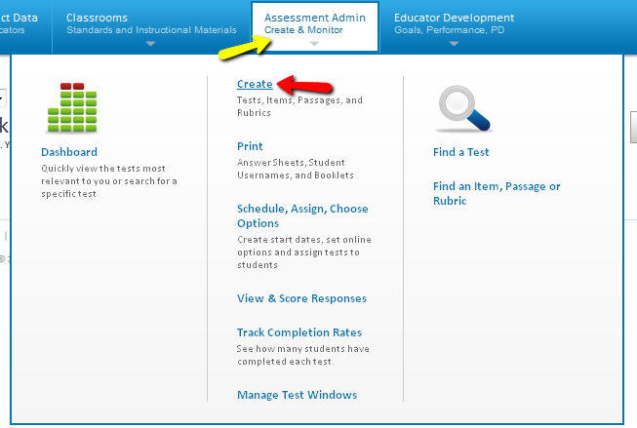

Choose **Option 1: Create an Express Test**, and select ***Start Now***.

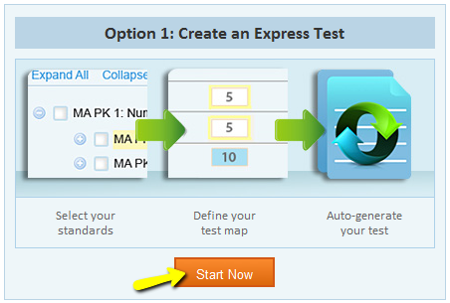

**Note:** Only express tests with a **Test Category** of ***Send Test to Gradebook*** will be exported to your Infinite Campus (IC) Gradebook and only classroom teachers will have the ability to create a test using this category.

Choose **Test Category**,and select ***Send Test to Gradebook.***

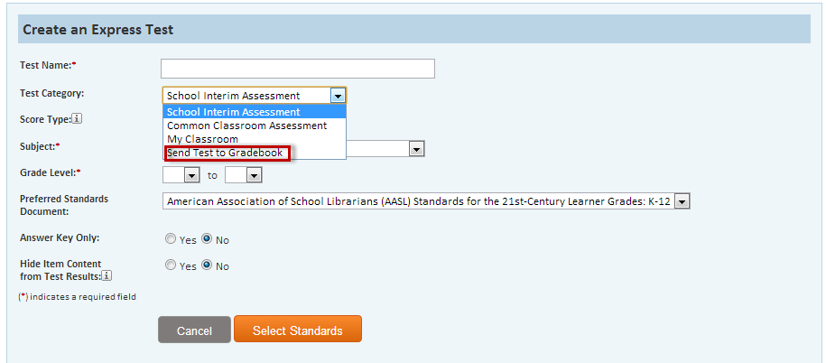

**Note:** The test category must be selected prior to scheduling the assessment for your students

Fill out the form with all required and appropriate fields, and then choose ***Select Standards*** to continue on.

Gradebook Export Notes

* **Test Name** – Limited to 50 characters (if longer, full name will not appear in Infinite Campus)
* **Test Category** – you must select “***Send Test to Gradebook***” or the test will not be sent to IC Gradebook.
* The test **must be scheduled** and **administered** or the test will not be sent to IC Gradebook.
* All tests will be loaded to “CIITS Tests” section of gradebook. If this section does not exist, the system will create it.
* This process occurs every evening.

**Note:** If you make a change to ***Assignment Name*** or ***Due Date*** in **CIITS** after the record has been imported into Infinite Campus, you will need to make the exact same change in Infinite Campus on the same day; otherwise it will create a duplicate assignment the next time the import runs that evening.

Check the standards you’d like to include on the test. If you don’t like the items generated, you will have the opportunity to replace them. Even if there are no items available for a standard, you can still pick it to serve as a placeholder. This pre-selection of standards will make the item entry faster.

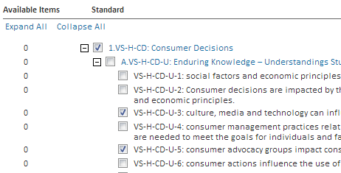

Fill out the form with all required and appropriate fields, and then choose ***Add to Test Map*** to continue.

If desired, use the Advanced Options to:

* exclude items that already appear on tests that have been scheduled for this school year
* exclude items with passages
* search for items meeting specific criteria

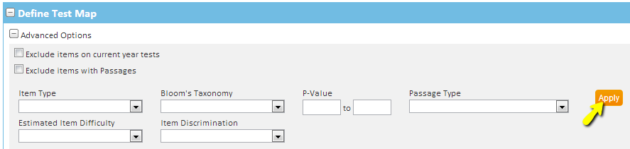

Be sure to click ***Apply***.

The standards you selected appear with the number of available items indicated. Use the trash can icon to remove an item, or the Select Standards options at the top to add more.

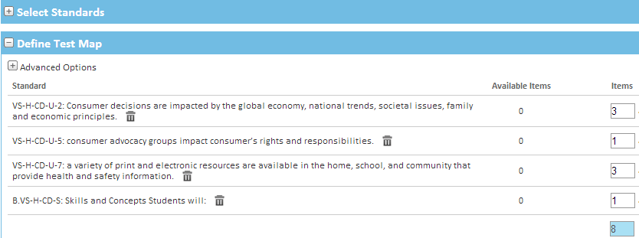

Choose ***Build Express Test*** to continue.

Now you will be able to accomplish the following:

* view item detail
* add additional items
* replace items
* remove items

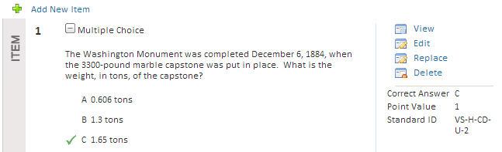

**Schedule** and **administer** the test to the students.

Gradebook Import Process Crosswalk

**CIITS > > > IC**

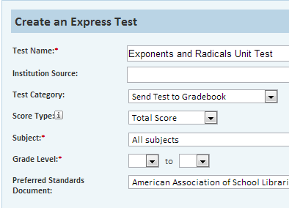 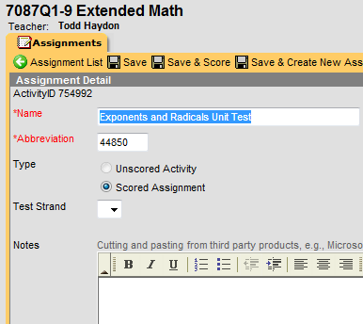

**CIITS > > > IC**

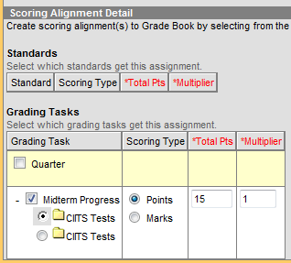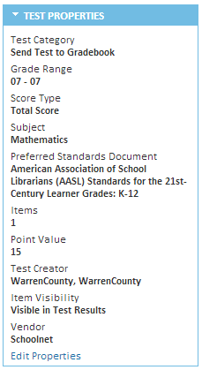

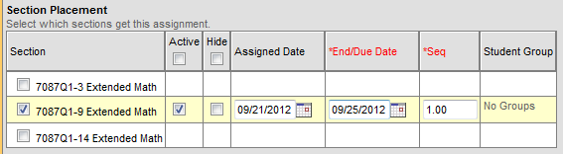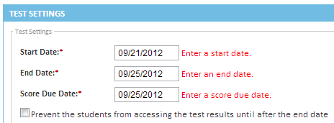

**CIITS**

**IC**

Accessing the Assignment in Infinite Campus

New CIITS Tests Category

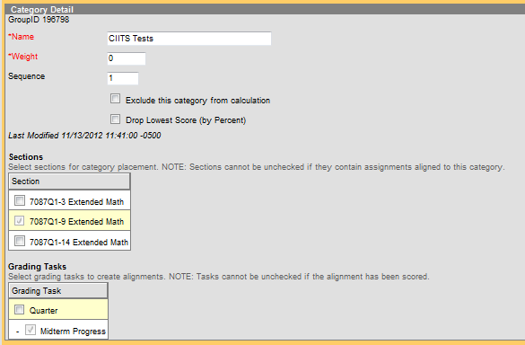

**Note:** There is a ***CIITS Tests*** category in each section. These fields can be changed independently from one section to another.

New Assignment

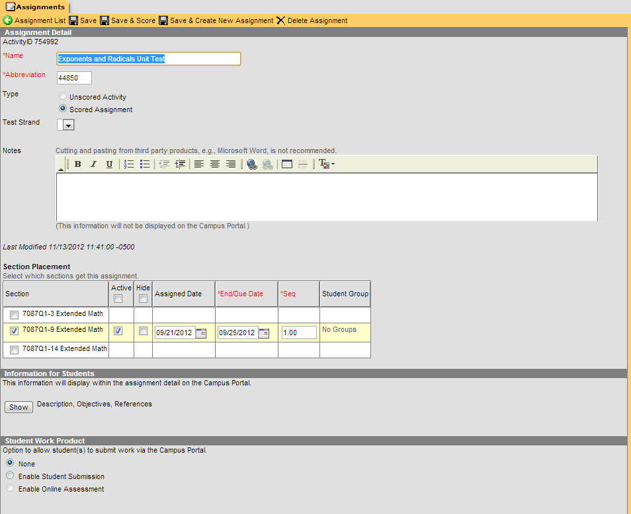

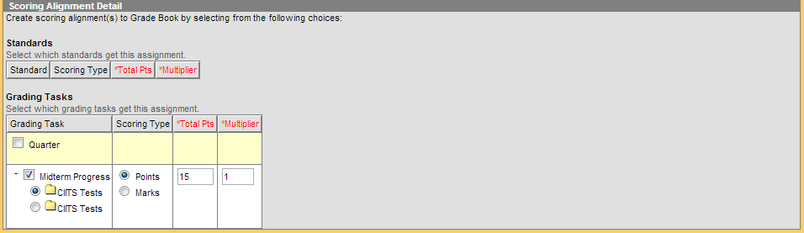

**Note:** The import program does not do any deleting. If a test that was previously imported to Infinite Campus is no longer wanted, it must be deleted manually. (Deleting the test in CIITS will not cause it to be deleted in Infinite Campus automatically.)